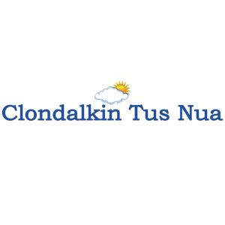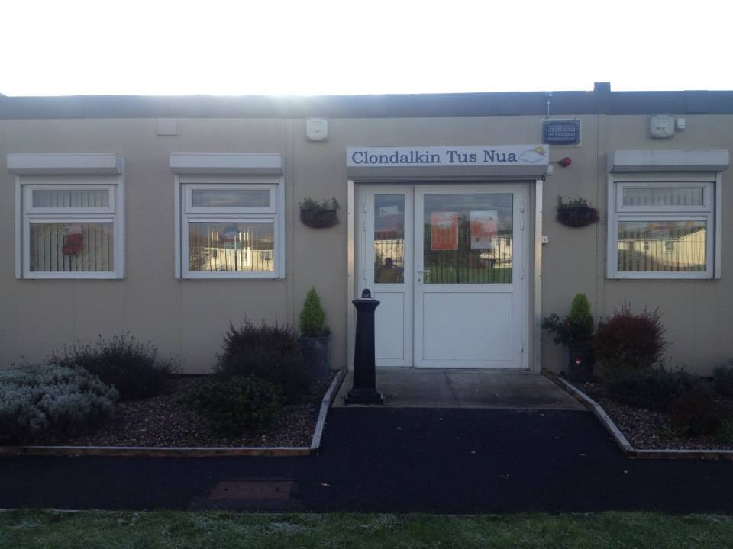
ANNUAL REPORT
2018

New Nangor Road, Clondalkin, Dublin 22
Tel: 01 4572938
Registered Charity Number: 20102586
Charity number: 21283
www.clondalkintusnua.ie

Contents Page

About Us 4

Services provided and outcomes 5

In this year 15

Donations 19

Board of Management - Staff 23

Annual events in 2018 24

Financial Summary 27

A copy of this report is available on our website www.clondalkintusnua.ie

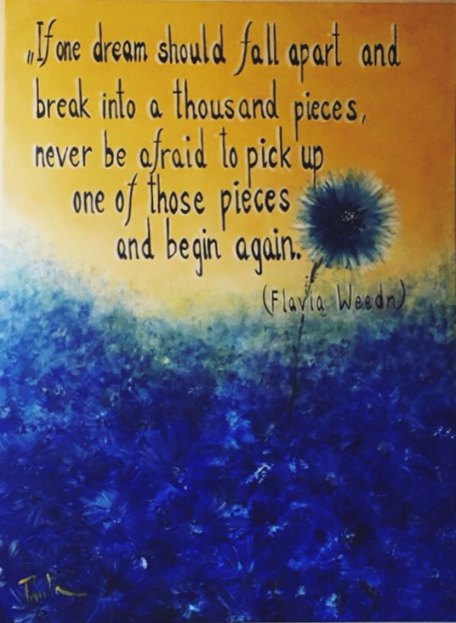

Painting at Reception

About Clondalkin Tús Nua

Clondalkin Tús Nua is a community based addiction support service based in South West Clondalkin, Dublin 22. The project was established in 1996 as a response to the local drug problem. As a community, we sought solutions to the drug problems in the area. This was achieved by developing practical and effective ways of working with statutory agencies and local service providers. Through funding from the Health Service Executive, D.S.P. and the Clondalkin Drugs and Alcohol Task Force. Clondalkin Tús Nua opened in September 1999. The centre is the first port of call for those requiring advice or information on issues of drug use and misuse. To date our centre remains accessible to anyone who wishes to avail of the wide range of services. Using a holistic approach, we endeavour to provide services that cater for the needs of the mind, body and spirit of the service user. These services are delivered in a professional manner that is flexible in a locally based, accessible venue and include Addiction Support, Rehabilitation Day Programme and Family Support.
2018 was an extremely busy year for the project with increased numbers of service users presenting to the service. It is hoped that this report will give the reader an insight into the service delivered by Clondalkin Tús Nua.

For more information, please log on to:

www.clondalkintusnua.ie

Services provided by
Clondalkin Tús Nua in 2018

Client work
Drop In:
Light refreshments and hot meals/snacks are an extremely important part of our Drop-In service, as for many of our clients this may be the only food they avail of on that day. It is also an opportunity to disseminate homeless packs and can provide a gateway into other services provided in Clondalkin Tús Nua
- Homeless Drop-In 09:30-11:00am
- Morning Open Access Drop-In 10:00 -11:00am
- Homeless Drop- In 02:30-04:00pm
- Afternoon Open Access Drop-In 03:00-04:00pm

- Clients availed of Drop In Service 106
- Individual attendance 1577
- Clients progress to the Key-Working process 12

Homeless Service:
- 2 x Daily Homeless Drop-In, hot food, showers and laundry service
- South Dublin County Council Homeless Outreach Worker provides support/information to homeless service users every second Wednesday afternoon 2:30pm-4:00pm
- Support when accessing homeless shelters/accommodation etc.
- Hygiene packs/health promotion
- Referrals to relevant agencies

- Clients accessed our Homeless Service 41
- Homeless Clients housed through support from SDCC
Homeless Outreach worker 4

Street Based Harm Reduction Service:

We provide a street based outreach service to work with the growing number of drug users, homeless or at risk of homeless service users in Clondalkin. Promoting harm reduction and good health/safe sex practice. Building non-judgemental, supportive relationships with homeless/active drug users.

- Monday to Thursday 9.00am to 4.45pm
- Friday 9.00am to 3.45pm

- Availed of Harm Reduction Service 157
- Number of exchanges 1291

SAFE Campaign (Support. Advice. Free Exchange. Empathy):

- Engaged with services 283
- Number of exchanges 266
- New clients 106
- Existing clients of CTN 4
- Availed of Harm Reduction at CTN 12
- Availed of Drop In service 9

Total number of exchanges 1557

Total number availed of Harm Reduction services 267

Addiction Support Sessions:
Monday - Thursday 09:00am- 05:00pm
Friday 09:00am- 04:00pm

To provide one to one sessions, set in a confidential and safe environment. Sessions could involve any of the flowing interventions:
- Initial Assessments
- Comprehensive Assessments
- Relapse prevention
- Crisis Intervention
- Harm Reduction
- Motivational Interviewing
- Individual Care Plans
- Referrals to treatment centres, counsellors, education/employment etc.,
- Referrals to Mental Health Services
- Progression routes
- Pre Assessments
- Community reintegration

- Clients availed of One to One Addiction Support 112
- One to One Sessions provided 1536
- Progressed to Station 1 Rehab Programme 17
- Progressed to treatment 10
- Progressed to fulltime employment 6
- Progressed to educational /training programme 7
- Referred to Step Ladder training programme 7
- Referred to SDCC Homeless Outreach Worker 21
- Referred to Adult Education Programme 15
- Referred to Community Welfare Service 35
- Referred to Prison Links Worker 7
- Referred into our service from CAS 3
- Referred into our service from Clondalkin Mental Health 11
- Referred into our service from Probation and Welfare 8

Gender Specific:
To provide gender specific support in relation to education, training, development of life skills, as well as to enhance and encourage emotional and personal development. Whether it is gender specific health issues, life skills, relationship or parental rights issues we can raise awareness within our client group and promote the need for a gender-balanced approach to these issues.

Referrals for Counselling:
TUSLA Child and Family Agency provide a budget to provide counselling to family members.
CD&ATF provide a budget to provide counselling to clients.

Complimentary Therapies:
Complimentary therapies are utilised in our project as part of our holistic approach to dealing with substance abuse. The uses are many fold in both situations where either clients or family members of those in addiction avail of this service. For individual clients these therapies contribute to reducing mental and physical stress levels and help to promote the clients ability to relax and in turn help in increasing the clients clear headedness when engaging in the service through the key working process. For clients who are near to entering residential treatment or are undertaking a home detox, complimentary therapies are indispensable in helping those suffering withdrawal symptoms and in general through releasing tension. For family members, complimentary therapies provide a vital “time out” or respite from the depression many suffer as a result of living through the process of addiction in the family.

Station 1 - Rehabilitation Day Programme

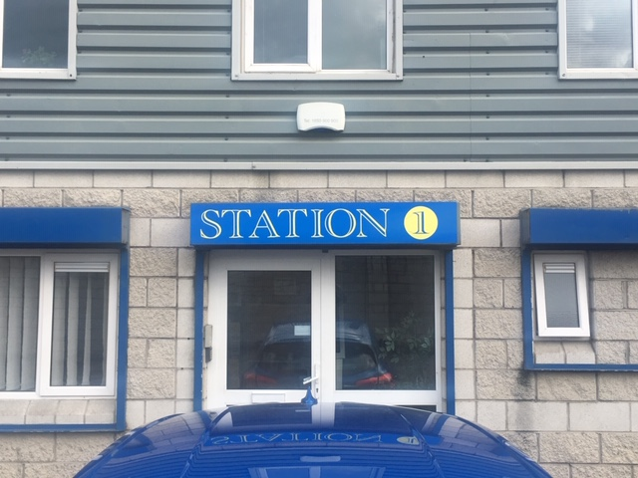

In 2006, Clondalkin Tús Nua highlighted the lack of locally based CE Rehabilitation places suitable for drug users in the early stages of recovery. Responsibility was given to Clondalkin Tús Nua and Clondalkin Drug Task Force Treatment & Rehabilitation Sub-Group to develop a proposal for a community based Rehabilitation Project.
In December 2007, Clondalkin Tús Nua launched Station 1 Rehabilitation & Development Programme.
Station 1 is a D.S.P. sponsored rehabilitation day programme, tailored to meet the needs of individuals in recovery from substance dependency.
Our aim is to provide a therapeutic setting to focus on returning to work and gaining economic/social independence, while providing a continuum of support in relation to recovery needs.

The main elements of the programme are Education, Holistic and Therapeutic
- 2 x 19.5 hours per week of which 16 hours are delivered on a group basis

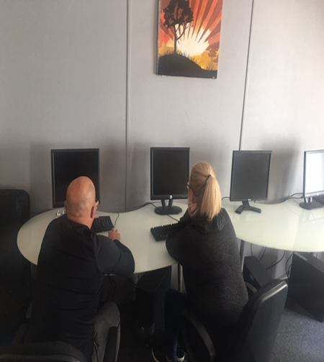
Education:
Our Educational Interventions are based on:
- Providing a learning environment that is interactive, collaborative and enjoyable.
- Providing material that is relevant to the needs of the participant group.
- Neutralising any negative associations from previous learning environments

Holistic:
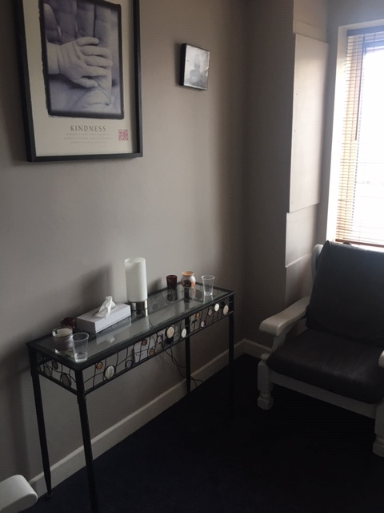
- Encouraging the participant to include healing strategies that support the whole person.
- Providing tools that help and increase control over one's behaviour in positive ways.
- Reducing tension, anxiety, depression and insomnia. Improving overall mental and physical wellbeing.

Therapeutic:
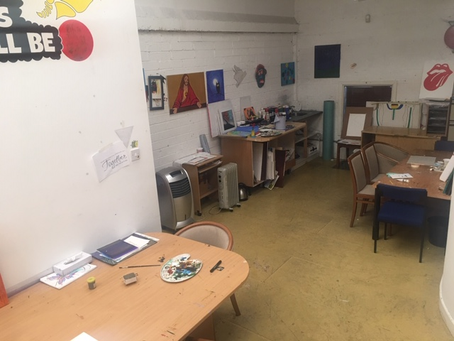

- Providing a core concept form that feeds into all elements of the programme.
- Providing group setting in which participants can gain a deeper understanding of the process of addiction.
- Providing and promoting a peer support setting to enable participants to relate with each other in a caring and supportive way.

C.T.N. (Station 1 Rehabilitation Programme) Client support:
- Pre programme Induction supports
- P1 – Stabilisation Programme
- P2 – Recovery prep programme
- P3 – Drug/Alcohol Free Day Programme
- P4 – Progression and Integration Pathways ACE Programme
- P5 – Aftercare (not Community Employment)

Pre Programme Induction Supports 32
- 14 clients referred on to P3/P4 Drug Free Programme
- 5 clients referred on to P1 Stabilisation Programme
- 6 clients referred on to P5 Aftercare Support
- 5 clients felt treatment was complete after shot-term interventions (4-12 weeks)
- 2 clients currently working on pre programme bases

- P1 Stabilisation Programme : P2 Recovery Preparation Programme 11
- 1 client completed Aiséirí Residential Service
- 1 client completed Cuan Dara and returned to our P3 Drug Free Programme
- 1 client referred to FROST Programme for follow up to community detox
- 1 client progressed to full-time employment
- 7 clients continued to attend this programme and have improved their quality of life. Illicit drug use had decreased and participation with other support service increased
- 2 clients currently on referral to Cuan Dara

- P3 Drug/Alcohol Free Day Programme 15
- 3 clients progressed to full-time employment
- 5 clients progressed onto P4 Progression and Integration Pathways ACE Programme
- 2 clients progressed on to adult education programme
- 2 clients completed Community Addiction Studies QQI L5
- 1 client attending part-time 3rd level education course
- 2 clients disengaged and were referred to CTN

P4 Progression and Integration Pathways ACE Programme 13
- 3 clients progressed to full-time employment in social care
- 1 client progressed to full-time education
- 6 clients currently on placement and in 3rd level education in the addiction sector
- 3 clients on work placement

P5 Aftercare: (not Community Employment) 10
- 10 clients accessed aftercare support in Station 1. This included key-working and case management , referrals for additional supports, brief and crisis interventions

In- house group interventions provided in 2018
- SMART RECOVERY 12 week block
- Weekly Therapeutic Peer Process Group
- Straight Ahead Group Recovery Programme
- Reduce the Use Group
- Cognitive Behavioural Skills Group
- Stress Management
- Relapse Prevention Skills Group
- Addiction Awareness Workshops
- Men’s Wellness Group
- Mini Mojo
- Art
- Self-Care and Wellbeing
- Health and Fitness
- Food and Nutrition
- Personal Interpersonal Skills QQI L3
- Woodwork QQI L3
- Painting and Decorating QQI L3
- Career Preparation QQI L3
- Literacy Skills Group
- Computer Skills Group

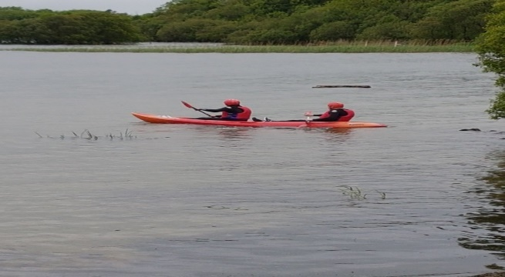

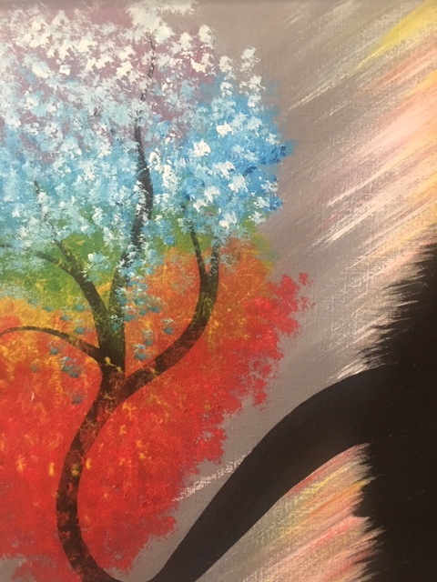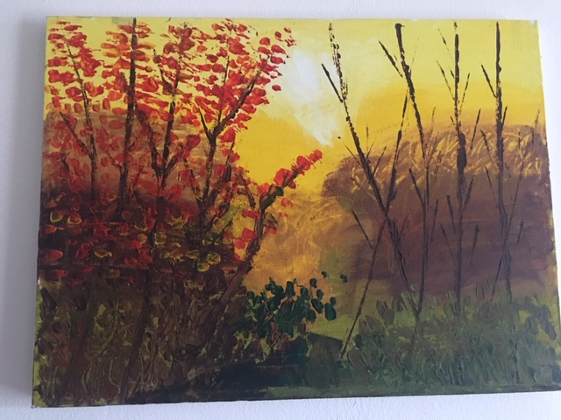ART WORK
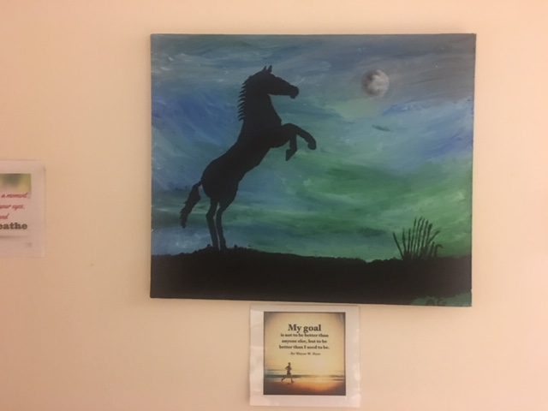

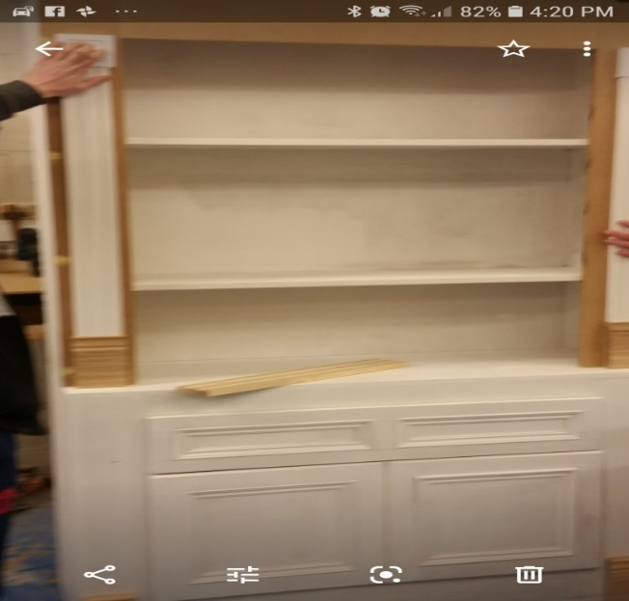
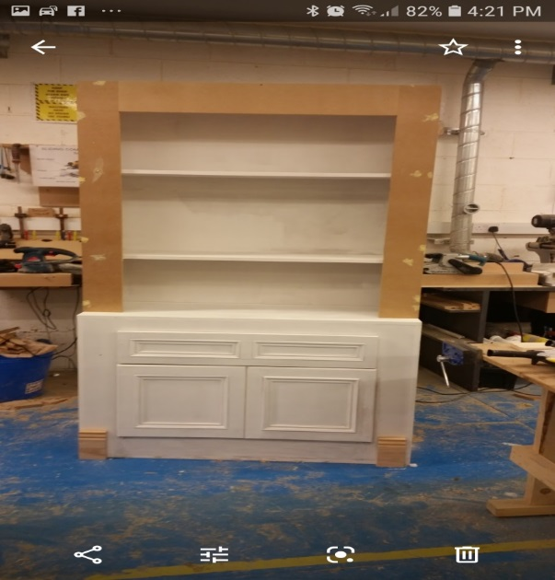

WOOD WORK QQI L3
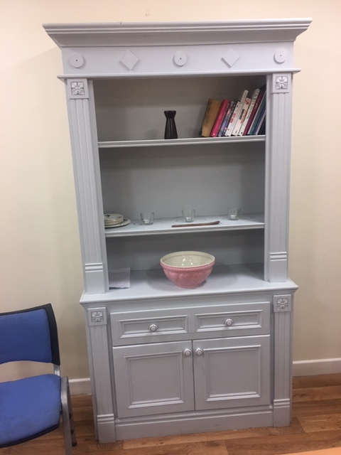

Family Support
Family Support is an integral tenant of the service our project provides. This support takes the form of one to one sessions, crisis intervention, education/therapeutic workshops, referrals for counselling, group support, and much more. It is implicit through the amount of work we do in this area that Family Support remains a vital resource of our project’s holistic approach to the challenge addiction represents in our community.
Through one to one sessions, the Family Support Worker is able to assess and identify the individual family member’s needs, develop a specific care plan and implement the supports needed. This is the most personal way in which we can address our family’s needs.

With the Wednesday night and Tuesday morning Family Support Groups we foster peer support from within the community and help family members develop crucial networks of peer support and friendship which help to minimise the feelings of isolation and self-blame which are so common around addiction in the family.

Monday – Thursday 9:00am to 5:00pm
Friday 9:00am to 4:00pm
Wednesday evening support group 7.30pm to 9.30pm

- Open access Contact centre
- One to One Support
- Group Support
- Education/Therapeutic workshops
- Access to counselling
- Complimentary therapies

- Availed of One to One support sessions 57
- One to One sessions 768
- Attended Evening Support Group 9
- Individual attendance 432
- Attended Morning Support Group 21
- Individual attendance 1577
- Family members attended education and therapeutic workshops 29
- Referred to Addiction Support (CTN) 4
- Members disengaged after receiving support 7

In this year

Insurance
Due to the huge rise in Insurance costs over the past 5 years, Clondalkin Tús Nua highlighted this issue with Citywide, H.S.E., Local TD’s, Clondalkin Drug & Alcohol Task Force and the Echo newspaper.
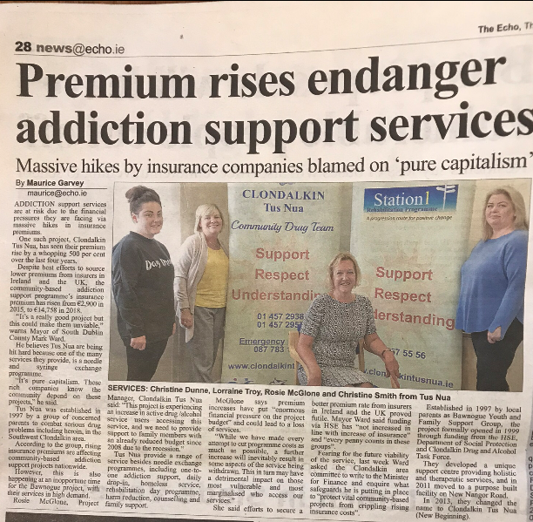

Citywide Presentation on Crack Cocaine use in Clondalkin
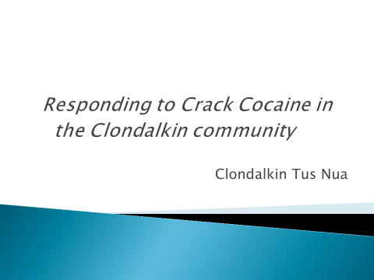

In March 2018, the project was invited by Anna Quigley from Citywide to present to a national meeting on the use of Crack Cocaine in the Clondalkin area.

Tuesday morning Family Support Group
This year we introduced a Tuesday morning support group for family members. This has been very successful with an average weekly attendance of approximately 12 parents. As well as providing peer led support it also offers an opportunity to host education mornings including Drug education, Intimidation etc.

Safe (Support, Advice, Free exchange and Empathy)
Background
In December 2017, An Garda Siochana made contact with the Clondalkin Drug & Alcohol Task Force to request some support to address an ongoing issue of drug use, anti-social behaviour and drug litter in Clondalkin Train Station. This had come from a request by Irish Rail due to numerous issues at the train station. In addition, there had been a serious incident before Christmas which resulted in the death of a young man who had come to Clondalkin to buy and use illicit drugs. The Gardai had also seen an increase in people from outside the area coming to their attention due to drug related crime.
A steering group was set up in December 2017, which comprised of the following membership:
- Clondalkin Drug & Alcohol Task Force
- An Garda Siochana
- Irish Rail Management
- CASP
- Clondalkin Tús Nua
- SDCC Elected Representative
This group discussed at length the issues that were presenting to both Irish Rail and the Gardai. They included:
- An increase in drug litter around the train station and in South West Clondalkin.
- An increase in antisocial behaviour at the train station.
- An increase in aggressive begging on the train.
- An increase in theft from passengers on the train.
- The death of an individual who was not from the area.
The Gardai noted that there had been a significant increase in people from Kildare, Westmeath, Cork, Kilkenny, Limerick, Laois and other parts of Dublin coming to their attention. These individuals / small groups were coming to Clondalkin to purchase Crack Cocaine, often in weight. They would often come to the attention of the Gardai in relation to their drug use or drug related crime and antisocial behaviour. A coordinated response was required in order to support those accessing the area to purchase drugs and to reduce drug related incidents at the train station.
Key pieces of work in 2018 include:
- A targeted response to the train station provided by Clondalkin Tús Nua for outreach harm reduction and CASP for outreach.
- An awareness campaign for Irish Rail, advertised along the train line and in the train station highlighting the services available for those travelling to Dublin to purchase illicit drugs.
- An approach was made to SDCC to look at drug litterbins at the train station and along the canal.
- Training to be provided to Irish Rail regarding universal precautions and overdose prevention.
- Community Gardai assisting with engagement and referrals into mainstream drug services.

Clondalkin Tús Nua & CASP
Clondalkin Tús Nua began providing the harm reduction service on Wednesday 24th January, meeting 4 trains in a 2-hour period. The outreach team have built up a strong working relationship with Irish Rail staff at the Clondalkin Train station.
CASP provide outreach to the train station one afternoon a week but do not provide backpack harm reduction. Due to the fact that the crack cocaine supply appears to be coming from South West Clondalkin and that Clondalkin Tús Nua are providing backpack NSP and crack pipes the majority of those accessing services are doing so through Clondalkin Tús Nua.
Progress to Date

- Engaged with services 283
- Number of exchanges 266
- New clients 106
- Existing clients of CTN 4
- Availed of Harm Reduction at CTN 12
- Availed of Drop In service 9
- Availed of homeless service and received tents, sleeping bags etc. 7
Going Forward
Irish Rail have made an official request to the Clondalkin Drug and Alcohol Task Force for additional resources to the Clondalkin train station for at least another full day where they have seen an increase in activity on the trains with high numbers exiting at Clondalkin and Heuston stations.
Staff members attended the launch of the SAFE Campaign in the Clayton Hotel. Paul Keegan presented a report on the Train station initiative including stats etc. The launch was very well attended and had great media coverage including radio interviews and newspaper reports.

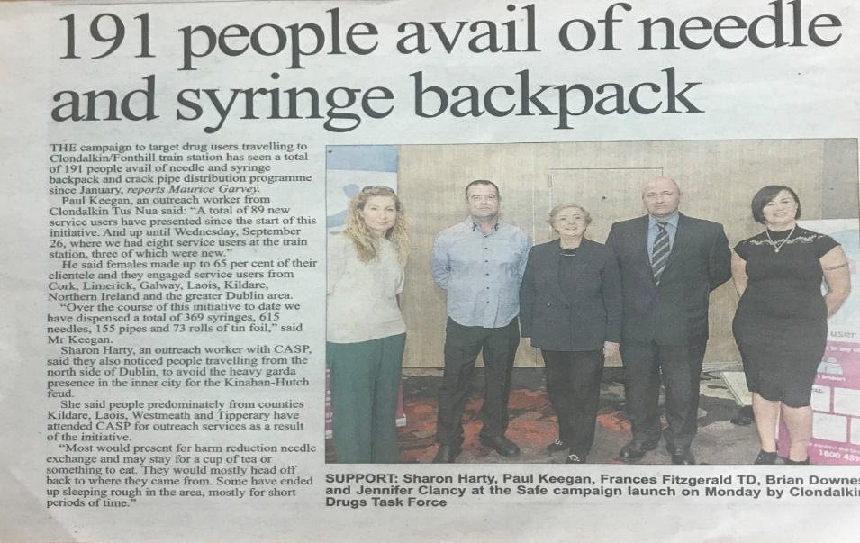
Donations
The project continues to receive donations from European FEAD, BIA Foods, Foodcloud, local businesses, South Dublin County Partnership, community members/groups etc. Too many to mention. These donations enable the project to support families in need and supports our rough sleeper/homeless service.
BIA Foods, food donations.
Every Wednesday morning the project gets a donation of food supplies from BIA Foods. These donations vary on a week-to-week basis and are used to make dinners for the drop in. Food not used for the drop in is distributed to needy families in the area.

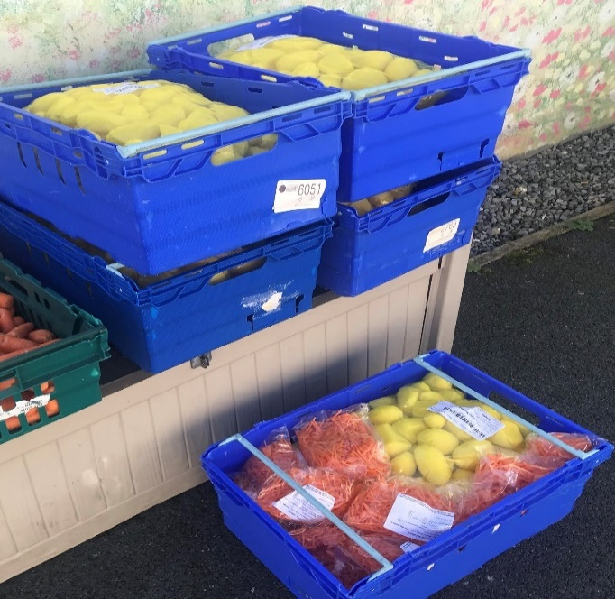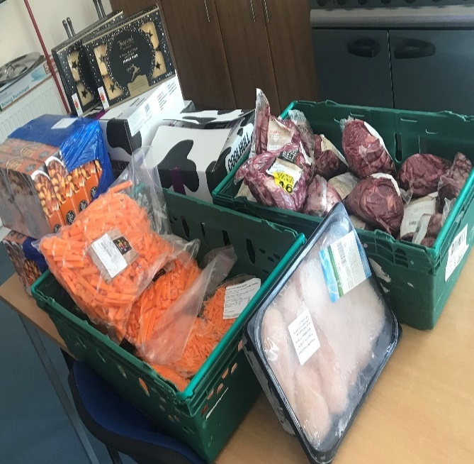

A very welcome donation of tents, sleeping bags, hats gloves and scarfs

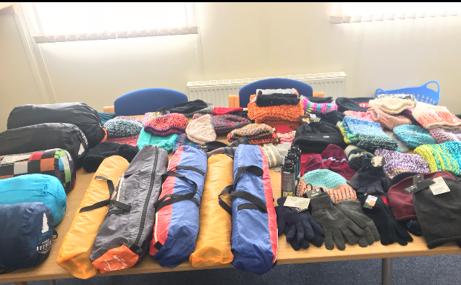

NOSTRA I.T. Solutions, Lucan: Huge donation of toys from the staff Christmas appeal. Kindly organised by a local community member, Elaine Hyland.
Thanks to staff at Clondalkin Tús Nua who repacked all the toys and distributed to very needy families, making a more enjoyable Christmas for all.

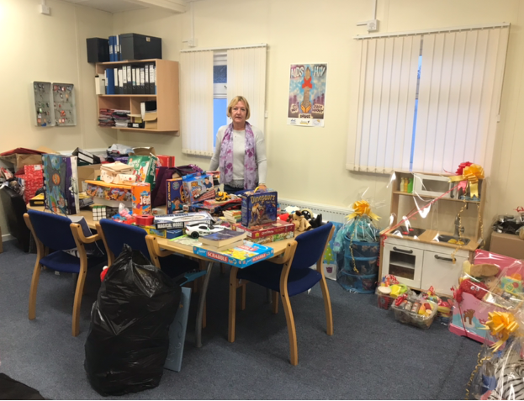
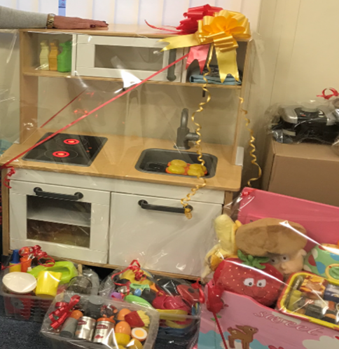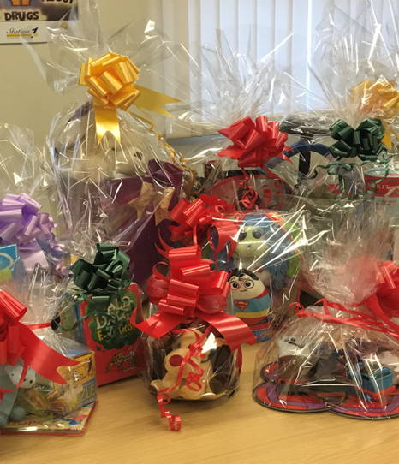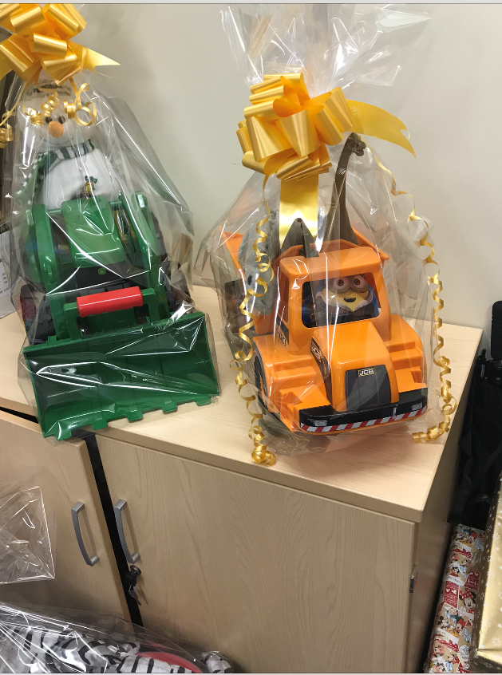

FEAD back to school packs:
The project received approximately 120 “back to school” packs, with a mixture of junior infants/senior infants and secondary school students. These packs were distributed to service user’s families and a few extra packs left over were passed on to the Clondalkin Traveller group.

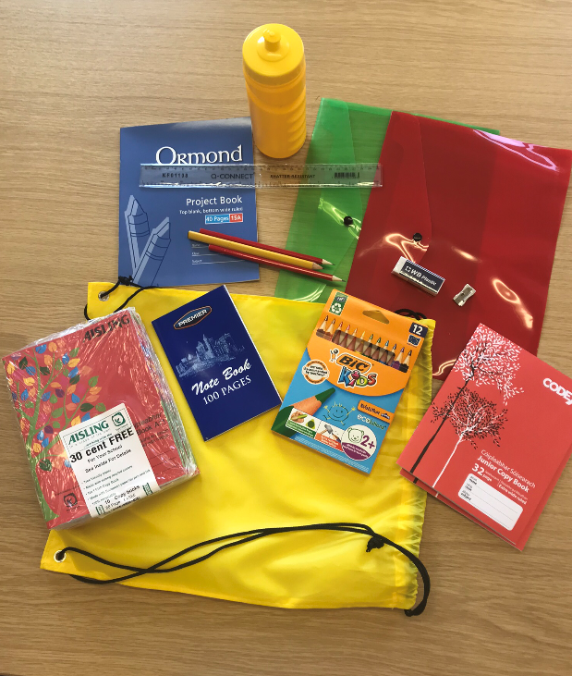

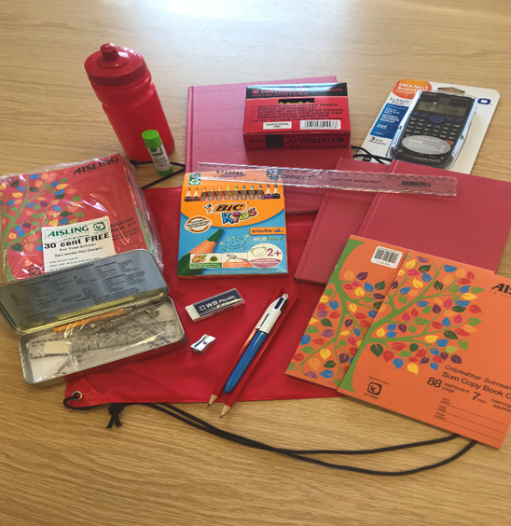

Avoca
Huge weekly donations of luxury foods from Avoca. All service user enjoyed their wonderful special breads and cakes

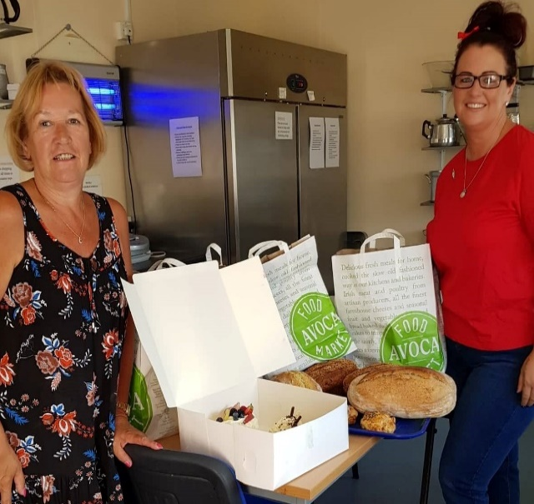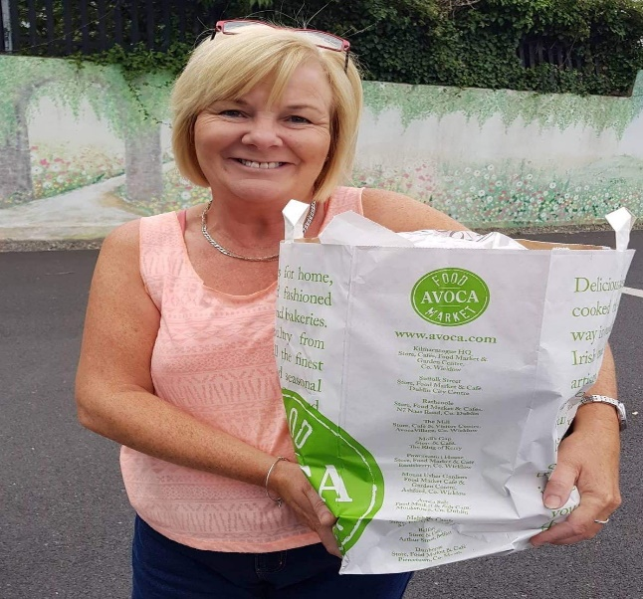

The Wren Boys (Buachaillí an Dreolín): very kindly donated an amount of €1000 to our homeless service.

On behalf of everyone at Clondalkin Tús Nua, we would like to take this opportunity to thank you all.

Board of Management and Staff Group

Board of Management
Brian Scanlan (Chairperson)
Kathleen O’Sullivan (Treasurer)
Judith Edmunds
Shane Lynch
Jamie Doran
Councillor Mark Ward

Clondalkin Tús Nua:
1 Project Manager
1 Community Employment Supervisor
1 Community Employment Assistant Supervisor
2 Key workers
1 Family Support Worker
1 Outreach Worker
9 C.E. participants
1 Tus participant

Clondalkin Tus Nua - Station 1 Rehabilitation Day programme:
1 Rehabilitation Coordinator
1 Community Employment Supervisor/key worker
1 Community Employment Assistant Supervisor/key worker
1 Project Worker
2 C.E. Support Workers
27 C.E. Rehabilitation Participants

Annual events in 2018

Women’s International Day 7th March 2018

84 Women attended for:

- Relaxing Therapies

- Beauty Therapies

- Group Meditation

- Lunch

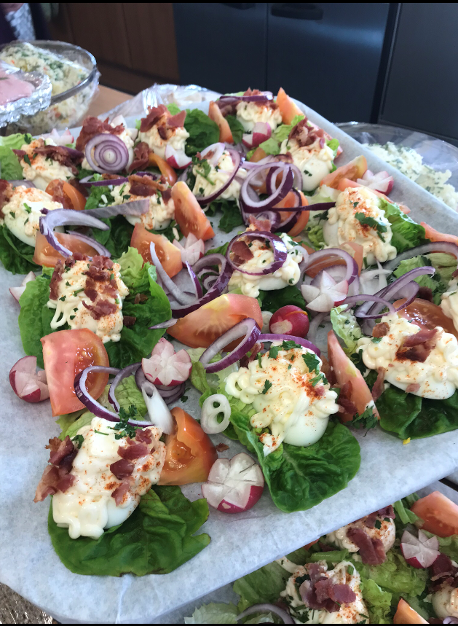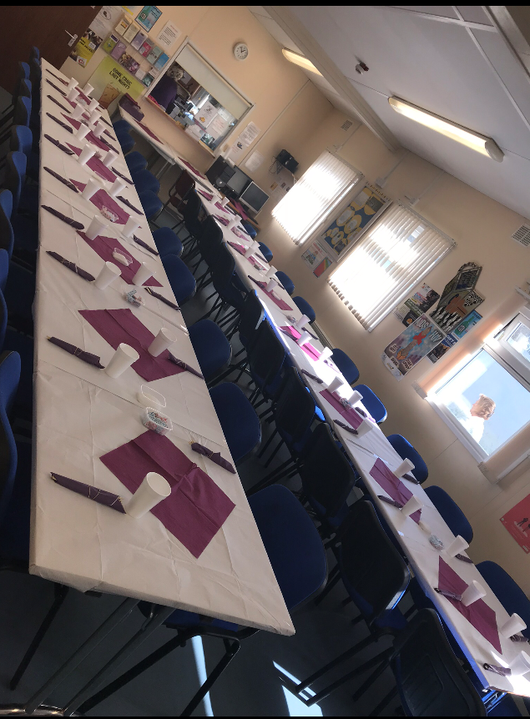

On Friday 22nd June, the project hosted a Family Fun Day for service users.

This was a very successful day and approximately 110 adults and children attended.

The day included:

- Face painting
- Arts and crafts activities
- Fun and Games
- Karaoke
- BBQ and Pizza’s

A special Thank you to Dominos Pizzas, Clondalkin who donated 16 Pizzas on the day

Annual Lighting of the Christmas tree

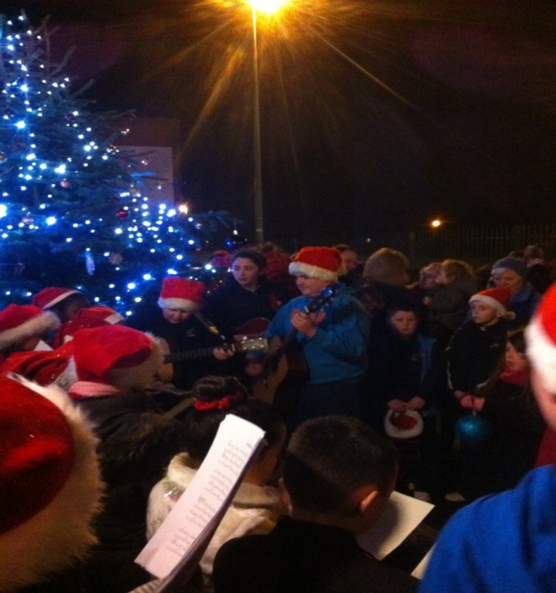

Approximately 100 service user’s attended the annual lighting of our Christmas tree followed by Carol singing and a special visit from Santa and his elves

Preparations for client annual Christmas dinner

19 came for dinner, followed by pool competition and karaoke with Christmas gifts etc.

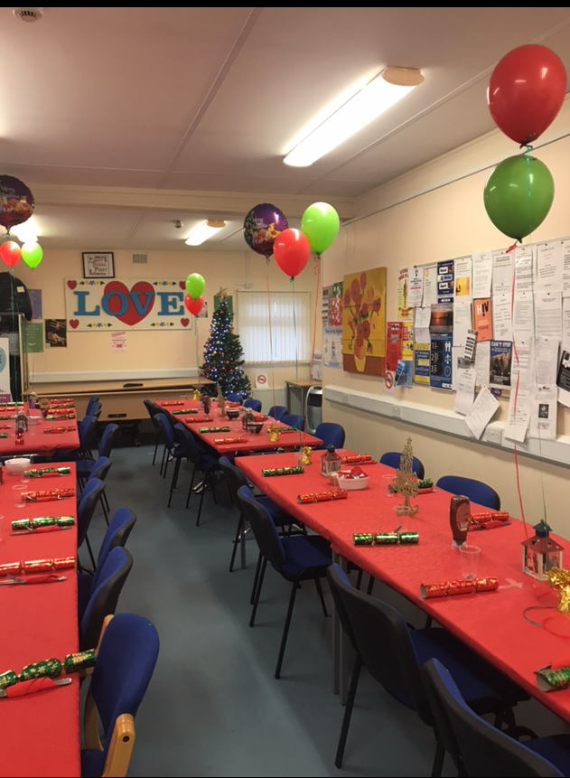

Funding sources

HSE Section 39 / Clondalkin Drug & Alcohol Task Force
Once off grants Clondalkin Drug & Alcohol Task Force
Department of Social Protection
TUSLA Family Support Agency

Financial Summary

Clondalkin Tús Nua have completed our financial audit for 2018 and the following extract was taken from the Director’s report and Financial Statements for the year ended 31st December 2018 and approved by the Board on the 25th June 2019

2018 2017
Income
Donations | 10,604 |  | 7,776
Department of Social Protection | 584,906 |  | 564,041
LDTF - Treatment & Rehabilitation | 249,311 |  | 249,311
LDTF - Prevention Programme | 71,066 |  | 71,066
HSE | 121,796 |  | 121,796
CDTF Once Off Income –  Client Counselling  Contribution Re Insurance | -  3,000  2,637 |  | 8,140  -  -
TUSLA | 6,700 |  | 6,700
 | ─────── |  | ───────
 | 1,050,019 |  | 1,028,830
 | ─────── |  | ───────

Expenditure
Materials | 10,534 |  | 6,270
Wages and salaries | 814,312 |  | 809,821
Employers PRSI Contributions | 45,673 |  | 47,646
Staff/ Participants Training | 8,380 |  | 10,631
Drop In Costs | 5,655 |  | 2,437
Once Off Funding | 5,637 |  | 7,523
Rent payable | 20,002 |  | 22,899
Insurance | 20,311 |  | 11,524
Equipment Costs | 8,247 |  | 6,047
Light and heat | 10,193 |  | 9,706
Repairs and maintenance | 9,694 |  | 11,806
Printing, postage and stationery | 2,862 |  | 5,451
Telephone | 5,089 |  | 4,934
Computer costs | 2,226 |  | 4,274
Tusla - Parent Support Counselling | 6,653 |  | 7,094
Women Fitness Group | 4,050 |  | -
Legal and professional | 2,612 |  | -
Rehabilitation Programme Costs | 14,026 |  | 16,632
Bank charges | 957 |  | 989
General expenses | 6,050 |  | 6,619

Auditor's remuneration | 4,499 |  | 4,747
Depreciation | 58,213 |  | 43,778
 | ─────── |  | ───────
 | 1,065,875 |  | 1,040,828
 | ─────── |  | ───────

Finance
Other interest | 7,832 |  | -
 | ─────── |  | ───────

Net deficit | (23,688) |  | (11,998)
 | ═══════ |  | ═══════

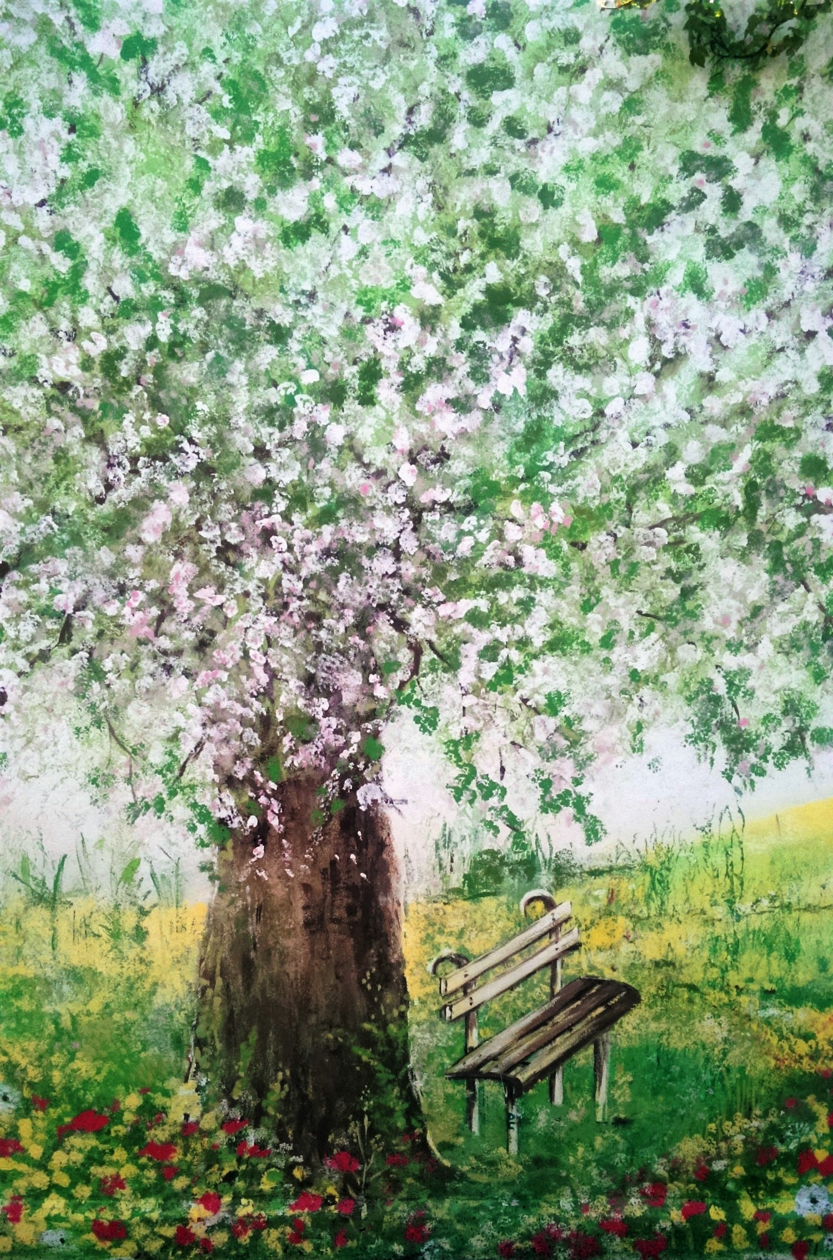

Clondalkin Tús Nua – Back wall Mural

