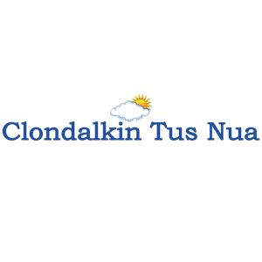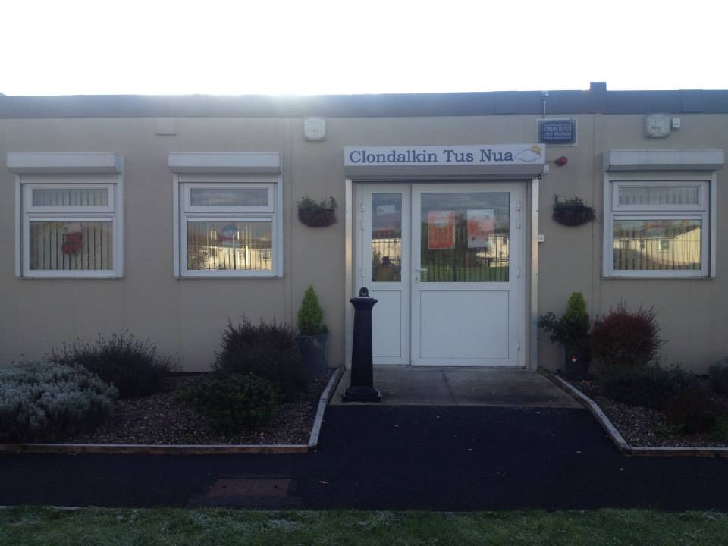
ANNUAL REPORT
2019

New Nangor Road, Clondalkin, Dublin 22
Tel: 01 4572938
Registered Charity Number: 20102586
Charity number: 21283
www.clondalkintusnua.ie

Contents Page

About Us 4

Services provided and outcomes 5

In this year 17

Donations 18

Board of Management - Staff 21

Annual events in 2019 22

Financial Summary 25

A copy of this report is available on our website www.clondalkintusnua.ie

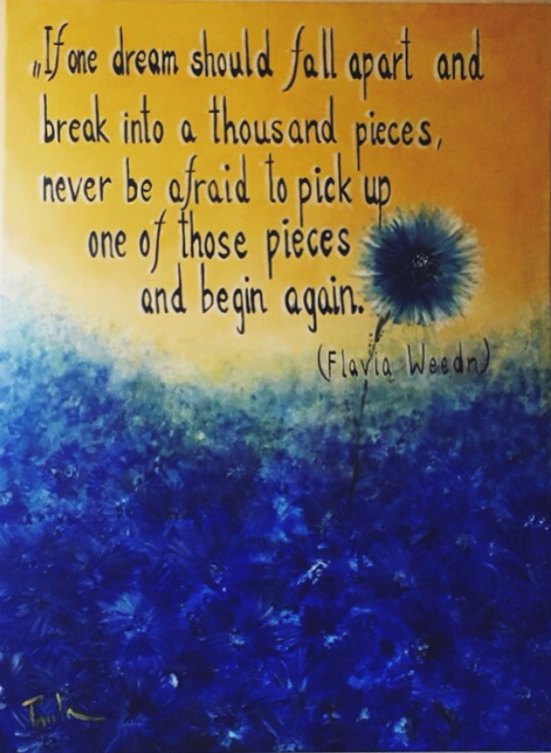

Painting at Reception

About Clondalkin Tús Nua

Clondalkin Tús Nua is a community based addiction support service based in South West Clondalkin, Dublin 22. The project was established in 1996 as a response to the local drug problem. As a community, we sought solutions to the drug problems in the area. This was achieved by developing practical and effective ways of working with statutory agencies and local service providers. Through funding from the Health Service Executive, D.S.P. and the Clondalkin Drugs and Alcohol Task Force. Clondalkin Tús Nua opened in September 1999. The centre is the first port of call for those requiring advice or information on issues of drug use and misuse. To date our centre remains accessible to anyone who wishes to avail of the wide range of services. Using a holistic approach, we endeavour to provide services that cater for the needs of the mind, body and spirit of the service user. These services are delivered in a professional manner that is flexible in a locally based, accessible venue and include Addiction Support, Rehabilitation Day Programme and Family Support.
2019 was an extremely busy year for the project with increased numbers of service users presenting to the service. It is hoped that this report will give the reader an insight into the service delivered by Clondalkin Tús Nua.

For more information, please log on to:

www.clondalkintusnua.ie

Services provided by
Clondalkin Tús Nua in 2019

Clondalkin Tus Nua
New Nangor Road, Clondalkin, Dublin 22
Station 1 Rehabilitation Programme
Unit C1 Station Road Business Park, Station Road, Clondalkin, Dublin 22

Monday 9am to 5pm
Tuesday 9am to 9.30pm
Wednesday 9am to 9.30pm
Thursday 9am to 5pm
Friday 8am to 4pm

Services provided | 1.Open access Contact centre  Clondalkin Tus Nua  New Nangor Road, Clondalkin, Dublin 22  - To engage with clients in addiction  - To provide face to face support to clients in active addiction, stabilised or drug free  - To bring about change in drug use  - To provide supports to those clients wishing to remain drug free  - To provide information  Target group:  - Active and stabilised drug users  - Homeless drug users  2. Addiction support  Clondalkin Tus Nua  New Nangor Road, Clondalkin, Dublin 22  To provide One to one sessions set in a confidential, safe environment. Sessions could involve any of the following interventions:  - Relapse prevention  - Crisis intervention  - Harm Reduction  - Motivational Interviewing  - Individual Care plans  - Referrals to Treatment centres, counselling,  - education/employment  - Referrals to mental Health Services, Complimentary therapies,  - Progression routes  - Aftercare  - Gender specific issues  - Initial and comprehensive assessments  - Advocacy  - Community reintegration  Target group:  Active, stabilised and drug free clients  3. Stabilisation services:  Clondalkin Tus Nua  New Nangor Road, Clondalkin, Dublin 22  One to one addiction support, gender specific group work, pre/post detoxification supports, access to counselling, referrals to rehabilitation /treatment programmes and advocacy  The aim of this action is to provide clients with a comprehensive needs assessment. To identify and develop a structured care plan that incorporates psychological problems, physical problems, social issues and legal problems  Target group:  - Stabilised service users  C.T.N. Client support:  Clondalkin Tus Nua  New Nangor Road, Clondalkin, Dublin 22  - Open access Drop in  - Homeless drop in  - Homeless service, incl. shower/laundry facilities  - Aftercare support  - Education/Therapeutic workshops  - Gender specific programmes  - Complimentary therapies  - Access to Counselling  - Outreach service  - Street based harm reduction service  - Rehabilitation Day Programme  Target group:  Active, stable and drug free service users  Street based Needle exchange:  Clondalkin Tus Nua  New Nangor Road, Clondalkin, Dublin 22  Target group:  Active service users  New in 2019  SAFE (Support, Advice, Free Exchange, Empathy)  A full time Assertive Case Manager has been employed under the SAFE Initiative to provide targeted harm reduction outreach to those using the train line to disembark in Clondalkin to purchase drugs. The Assertive Case Manager will engage with people who are high risk and provide NSP and crack pipe distribution, information and support regarding services in their own areas, conduct assessment of need and provide referral pathways into services in their own locality and support a shared care approach for those most marginalised from services  Offering case management services on an outreach basis to the people who are most at risk and are the most complex and entrenched cases in the Clondalkin / Kildare area. Through access to a structured package of care, intervention and support; this service will provide direct service provision to adults who are actively using drugs.  C.T.N. (Station 1) Client support:  Station 1 Rehabilitation Programme  Unit C1 Station Road Business Park, Station Road, Clondalkin, Dublin 22  The rehabilitation programme currently runs 5 days per week and provides a diverse and integrative group recovery intervention model. We have developed a tier based approach to support the individual through the various stages of change and building of recovery capital that is achievable and maintainable.  - Pre programme induction supports  - Stabilisation Programme P2 Recovery Preparation Programme  - P3 Drug/alcohol free day programme  - P4 Progression and Integration Pathways ACE Programme  - P5 Aftercare:10 – (not Community Employment)  Target group:  Stabilised/drug free CE Participants  Parent Support:  Clondalkin Tus Nua  New Nangor Road, Clondalkin, Dublin 22  - Open access Contact centre  - One to one support  - Group support  - Education/Therapeutic workshops  - Access to counselling  - Complimentary therapies  Target group:  Family members incl. parents, partners, grand parents and siblings affected by addiction in their homes  Clondalkin Tus Nua accommodates:  - Tuesday and Wednesday evening AA Meetings  - Tuesday evening Al Anon meetings  - SDCC Homeless Outreach worker every 2nd Wednesday afternoon during our Drop in Time
Quantum of Services Provided | One to one addiction support  Crisis intervention, Referrals to primary health care, homeless services and HSE addiction services  Pre/post detoxification supports, referrals to rehabilitation /treatment programmes and advocacy  Monday to Friday 9.00am to 5.00pm  Open access drop in  - am to 11.00 am Monday to Friday  2.30pm to 4.00pm Monday to Thursday  1.30pm to 3.00pm Friday  Street based Needle exchange  9.30 to 4.30 Monday to Thursday  9.30 to 3.30 Friday  SAFE  Clondalkin Tus Nua - Monday Wednesday and Friday  Kildare (Aras) - Tuesday and Thursday  (Programme in development)  Rehabilitation Day programme (Station 1)  The rehabilitation programme currently runs 5 days per week and provides a diverse and integrative group recovery intervention model. We have developed a tier based approach to support the individual through the various stages of change and building of recovery capital that is achievable and maintainable.  Morning and afternoon programmes  Morning programme - 9.00 to 1.00  Afternoon – 1.00 to 5.00  - Pre programme induction supports  - P2 Recovery Preparation Programme  - P3 Drug Free Programme  - P4 Progression and Integration Pathways ACE Programme  - P5 Aftercare  Target group: Stabilised and drug free clients  Family support  One to one and group support  One to one – Monday, Tuesday, Thursday Friday 9.00 to 5.00  Wednesday 2.00 to 5.00  Group support: Tuesday morning support group 9.30 to 12.30  Wednesday evening support group 7.00 to 9.30
Users Availing of the Service | One to one addiction support: 91  One to one sessions 1371  - Progressed to Station 1 Rehab programme: 6  - Progressed to Residential Treatment:2  - Progressed to Fulltime employment: 4  - Progressed to education/training programmes: 2  - Referred to Step ladder training programme: 2  - Referred into our service from TUSLA: 3  - Referred into our service from community doctors:15  - Referred into our service from Clondalkin Mental Health :3  - Referred into our service from Probation and Welfare: 2  Drop in:  Clondalkin Tus Nua  New Nangor Road, Clondalkin, Dublin 22  - 116 clients availed of Drop in service  - 2200 individual attendances  - 18 clients engaged in the key working process  - 2 clients progressed to Station 1  - 2 clients referred to treatment  - Clients accessed our homeless service: 36  - Referred to SDCC Homeless outreach worker: 20  - Housed by SDCC Homeless outreach worker: 4  Street based Harm Reduction Service:  Clondalkin Tus Nua  New Nangor Road, Clondalkin, Dublin 22  - Availed of Harm Reduction service: 163  - Number of exchanges: 968  SAFE  - Engaged with the service: 154  - Number of exchanges: 153  - New Clients: 33  Total number of exchanges 1121  Total number availed of Harm Reduction service: 317  Rehabilitation Programme:  Station 1 Rehabilitation Programme  Unit C1 Station Road Business Park, Station Road, Clondalkin, Dublin 22  - 49 clients accessed services in Station 1  Pre programme induction supports: 26  - 10 clients referred on to Drug Free Programme  - 5 clients referred on to P1 Stabilisation Programme / P2  - 6 clients referred on to P5 aftercare supports.  - 5 clients felt treatment was complete after shot-term interventions(4-12weeks)  P1 Stabilisation Programme: 16  - 3 Clients were referred to and completed residential treatment / detox  - 3 Clients move to Drug Free Programme  - 1 client was remanded in custody/ prison  - 9 clients continued to attended this programme and have improved their quality of life, illicit drug use has decreased and participation with other support service increased  - 2 Client currently working on referral for Cuan Dara  - 1 Client awaiting a bed in St Francis Farm Residential Programme  P2 Recovery Preparation Programme:16  - 3 Clients completed Cuan Dara Residential Detox, 2 progressed on to Keltoi and all 3 returned to our P3 Drug free programme  - 1 Client completed High Park Residential and moved on to a training programme.  - 1 Client completed Cuan Mhuire and progressed on to our Drug free programme  - 1 client completed community detox and was referred to P3 Drug Free Programme  - 1 Client relapsed and was referred to CTN main service  - 2 Clients are currently in preparation for Cuan Dara Residential Detox.  - 1 Client community returns programme was revoked and he is currently in prison  - Remainder of clients working on reducing their methadone levels with the long-term aim of detox  P3 Drug Free Programme: 12  - 5 Clients progressed into full-time employment  - 2 Clients progressed onto P4 Progression and Integration Pathways ACE Programme  - 2 Clients attending part-time 3rd level educational courses  - 3 Clients disengaged / felt treatment was complete and did not request follow on supports  P4 Progression and Integration Pathways ACE Programme: 9  - 2 Clients progressed to full-time employment  - 1 Client progressed to full-time education placement  - 8 Clients accessed work based placement  - 3 Clients currently on long term work placement  P5 Aftercare: 9  - 9 clients accessed aftercare supports in Station 1 this included key working and case management, referrals for additional supports, brief and crisis interventions, counselling.  In house group interventions provided in 2019  - SMART RECOVERY 12 week blocks  - Communication Skills  - Weekly Therapeutic Peer Process Group  - Straight Ahead Group Recovery Programme  - Reduce the Use Group  - Cognitive Behavioural Skills Group  - Stress Management  - Relapse Prevention Skills Group  - Addiction Awareness Workshops  - Heads Up Programme  - Yoga  - Art  - Self-Care and Wellbeing  - Health and Fitness  - Food and Nutrition  - Acupuncture  - Data Base QQI L3  - Health and Safety in the Work place  - Literacy Skills Group  - Computer Skills Group  Family Support:  Clondalkin Tus Nua  New Nangor Road, Clondalkin, Dublin 22  - Availed of one to one support sessions: 72  - 61 new service user’s in 2019  - One to one sessions: 305  - Attended Evening Support Group: 11  - Individual attendances: 258  - Attended Morning Support Group: 21  - Individual attendances: 295  - 31 family members attended education and therapeutic work shops  - Referred to Addiction support (CTN) 2  - 3 members disengaged after receiving support

Station 1 - Rehabilitation Day Programme

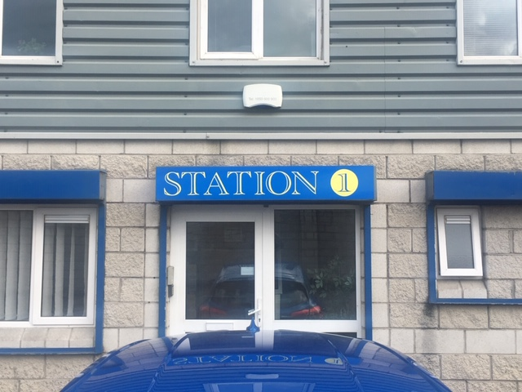

In 2006, Clondalkin Tús Nua highlighted the lack of locally based CE Rehabilitation places suitable for drug users in the early stages of recovery. Responsibility was given to Clondalkin Tús Nua and Clondalkin Drug Task Force Treatment & Rehabilitation Sub-Group to develop a proposal for a community based Rehabilitation Project.
In December 2007, Clondalkin Tús Nua launched Station 1 Rehabilitation & Development Programme.
Station 1 is a D.S.P. sponsored rehabilitation day programme, tailored to meet the needs of individuals in recovery from substance dependency.
Our aim is to provide a therapeutic setting to focus on returning to work and gaining economic/social independence, while providing a continuum of support in relation to recovery needs.
The main elements of the programme are Education, Holistic and Therapeutic
- 2 x 19.5 hours per week of which 16 hours are delivered on a group basis

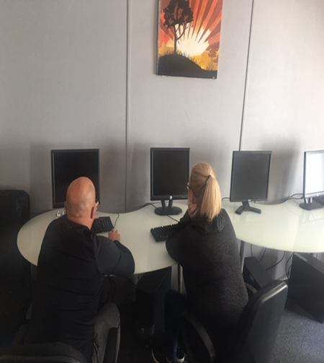
Education:
Our Educational Interventions are based on:
- Providing a learning environment that is interactive, collaborative and enjoyable.
- Providing material that is relevant to the needs of the participant group.
- Neutralising any negative associations from previous learning environments

Holistic:
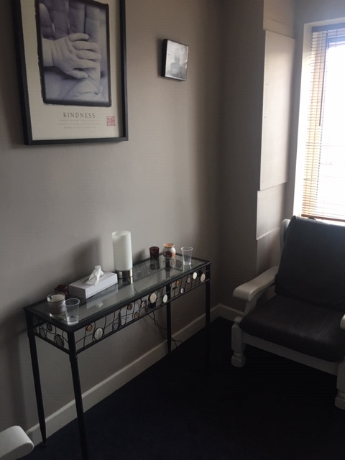
- Encouraging the participant to include healing strategies that support the whole person.
- Providing tools that help and increase control over one's behaviour in positive ways.
- Reducing tension, anxiety, depression and insomnia. Improving overall mental and physical wellbeing.

Therapeutic:
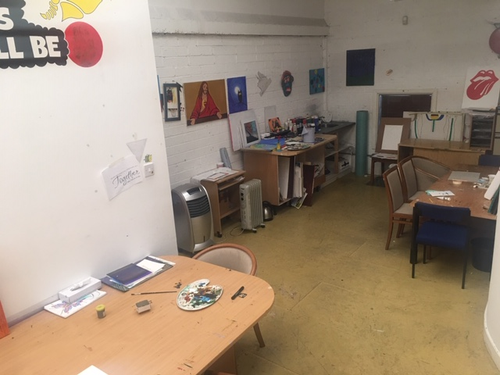

- Providing a core concept form that feeds into all elements of the programme.
- Providing group setting in which participants can gain a deeper understanding of the process of addiction.
- Providing and promoting a peer support setting to enable participants to relate with each other in a caring and supportive way.

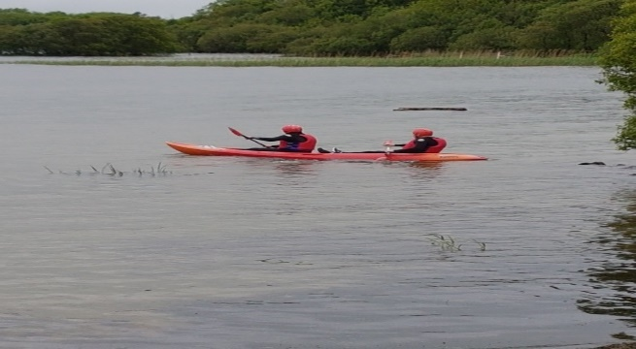

Family Support
Family Support is an integral tenant of the service our project provides. This support takes the form of one to one sessions, crisis intervention, education/therapeutic workshops, referrals for counselling, group support, and much more. It is implicit through the amount of work we do in this area that Family Support remains a vital resource of our project’s holistic approach to the challenge addiction represents in our community.
Through one to one sessions, the Family Support Worker is able to assess and identify the individual family member’s needs, develop a specific care plan and implement the supports needed. This is the most personal way in which we can address our family’s needs.

With the Wednesday night and Tuesday morning Family Support Groups we foster peer support from within the community and help family members develop crucial networks of peer support and friendship which help to minimise the feelings of isolation and self-blame which are so common around addiction in the family.

Monday – Thursday 9:00am to 5:00pm
Friday 9:00am to 4:00pm
Wednesday evening support group 7.30pm to 9.30pm

- Open access Contact centre
- One to One Support

In this year

SPIRITAN 5 SCHOOLS GALA DINNER WITH CHARITY AUCTION
DONATION
15th February 2019
- Blackrock College
- St Mary’s College
- St Michael’s College
- Rockwell College
- Templeogue

Fr. Brian from our local church (The Church of the Transfiguration) in Bawnogue nominated Clondalkin Tus Nua for the 5 school charity auction event.
We Received a Cheque from Fr Brian Starke and David Coen for the amount of €17,887.22.
This funding provided tents, sleeping bags, a storage container, 2 computers for the drop in room, and clothing and plans for a wheelchair ramp in the future
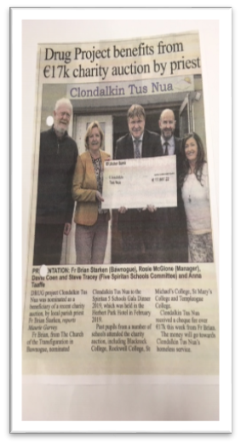
On behalf of the rough sleepers/homeless service users of Clondalkin Tus Nua we would like to say a HUGE THANK YOU to everyone involved and everyone who donated.

TWO COMPUTERS FOR THE DROPIN, THIS ALLOWS HOMELESS CLIENTS GAIN ACCESS TO E. MAILS, PROPERTY WEBSITES ETC.
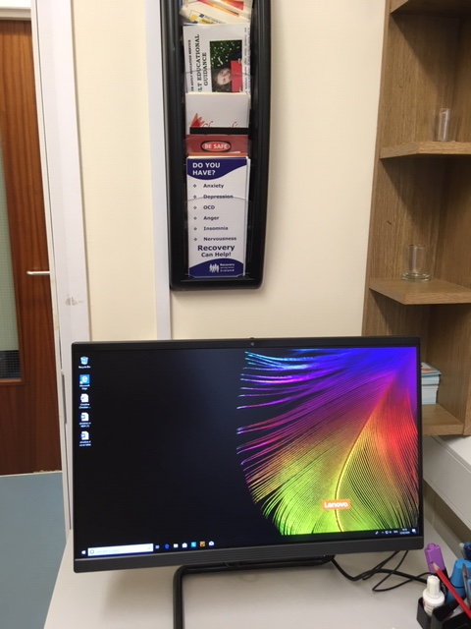

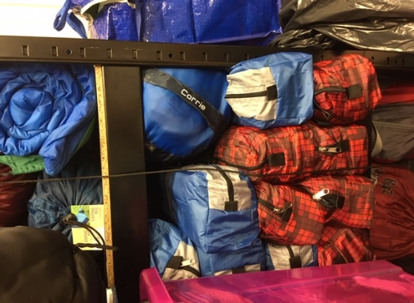

SELECTION OF TENTS AND SLEEPING BAGS

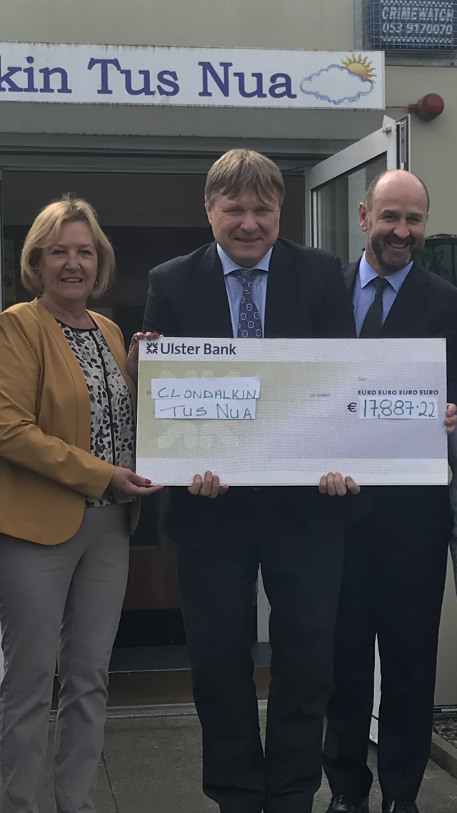
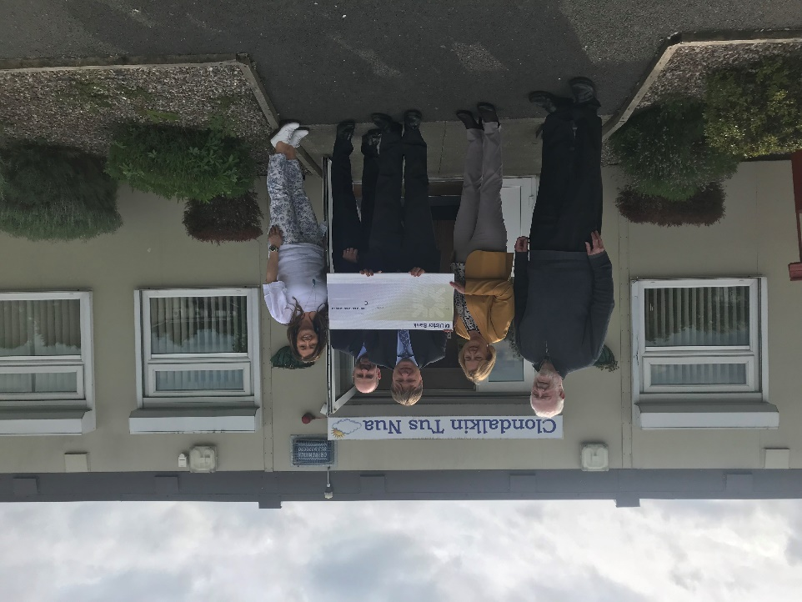

DONATIONS
FOOD CLOUD

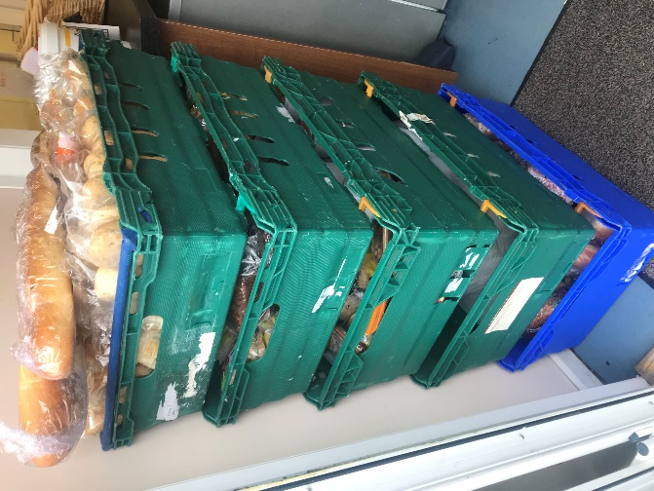
TENTS
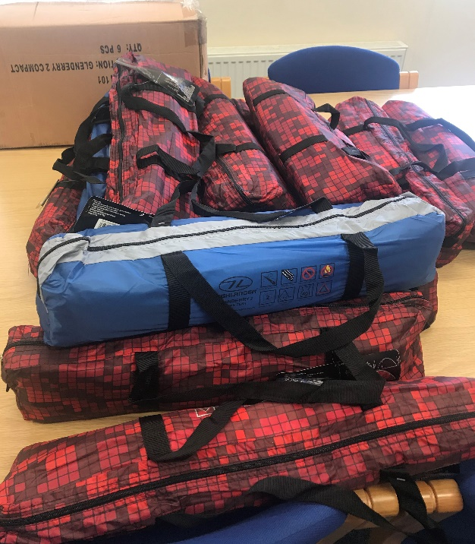

On behalf of everyone at Clondalkin Tús Nua, we would like to take this opportunity to thank you all.

Board of Management and Staff Group

Board of Management
Brian Scanlan
Kathleen O’Sullivan (Treasurer)
Judith Edmunds
Jamie Doran (Chairperson)
Margaret Lawlor
Lisa Coleman

Clondalkin Tús Nua:
1 Project Manager
1 Community Employment Supervisor
1 Community Employment Assistant Supervisor
2 Key workers
1 Family Support Worker
1 Outreach Worker
1 Assertive Case Manager
9 C.E. participants
1 Tus participant

Clondalkin Tus Nua - Station 1 Rehabilitation Day programme:
1 Rehabilitation Coordinator
1 Community Employment Supervisor/key worker
1 Community Employment Assistant Supervisor/key worker
1 Project Worker
2 C.E. Support Workers
27 C.E. Rehabilitation Participants

Annual events in 2019

Women’s International Day 27th February 2019

78 Women attended for:

- Relaxing Therapies

- Beauty Therapies

- Group Meditation

- Lunch

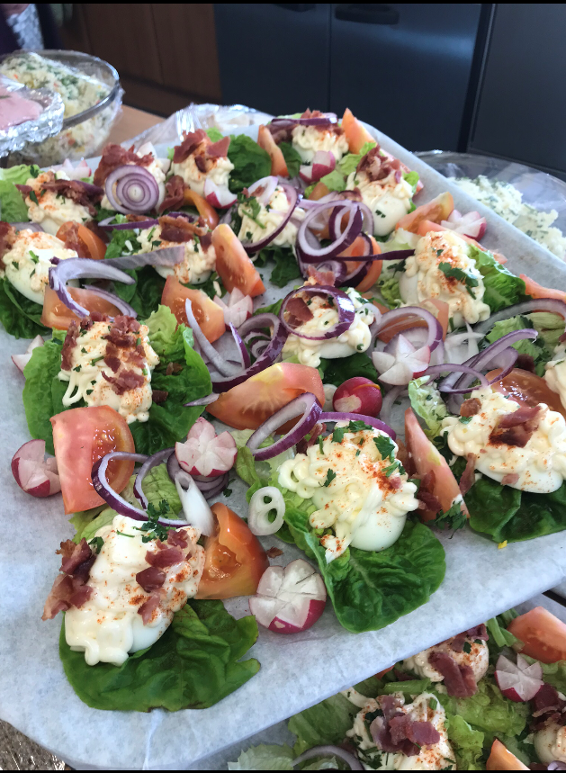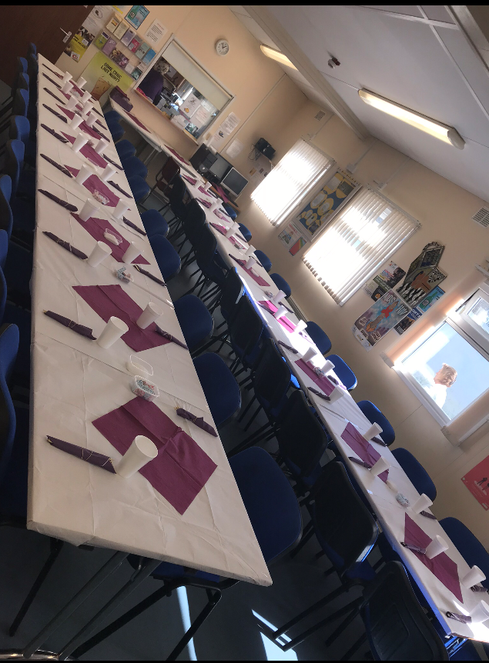

On Friday 21nd June, the project hosted a Family Fun Day for service users.

This was a very successful day and approximately 103 adults and children attended.

The day included:

- Face painting
- Arts and crafts activities
- Fun and Games
- Karaoke
- BBQ and Pizza’s

A special Thank you to Dominos Pizzas, Clondalkin who donated 16 Pizzas on the day

Annual Lighting of the Christmas tree

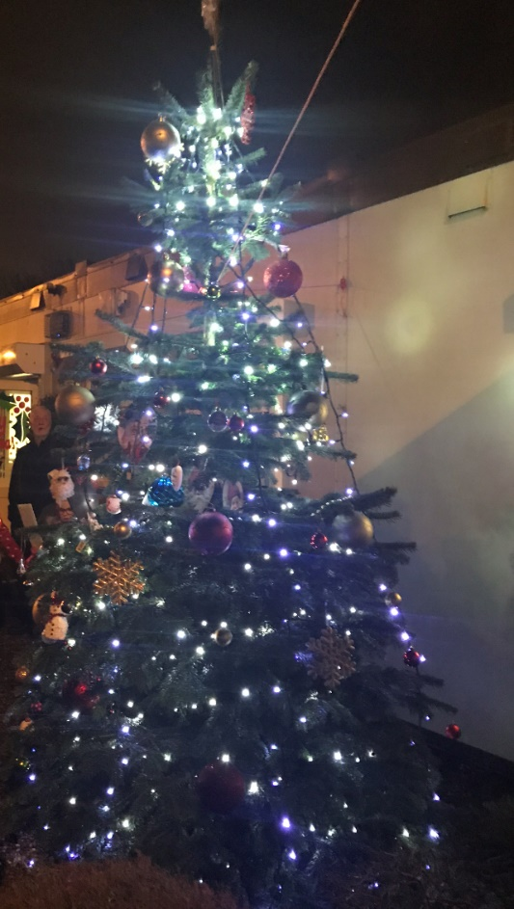

Approximately 100 service user’s attended the annual lighting of our Christmas tree followed by Carol singing and a special visit from Santa and his elves

Preparations for client annual Christmas dinner

14 came for dinner, followed by pool competition and karaoke with Christmas gifts etc.

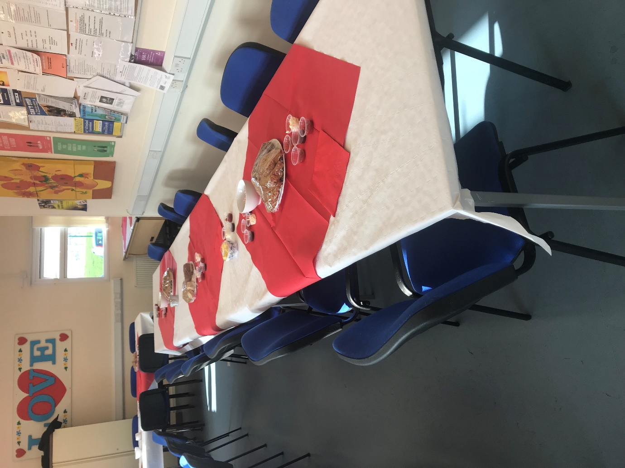

Funding sources

HSE Section 39 / Clondalkin Drug & Alcohol Task Force
Once off grants Clondalkin Drug & Alcohol Task Force
Department of Social Protection
TUSLA Family Support Agency

Financial Summary

Clondalkin Tús Nua have completed our financial audit for 2019 and the following extract was taken from the Director’s report and Financial Statements for the year ended 31st December 2019 and approved by the Board on the 25th June 2020

2019 2018
I
Income
Donations | 35,909 |  | 10,604
Department of Social Protection | 544,023 |  | 584,906
LDTF - Treatment & Rehabilitation | 249,311 |  | 249,311
LDTF - Prevention Programme | 71,086 |  | 71,066
HSE | 121,796 |  | 121,796
CDTF Once Off Income | 6,542 |  | 5,637
TUSLA | 6,700 |  | 6,700
Safe Program Strand | 40,000 |  | -
 | ─────── |  | ───────
 | 1,075,367 |  | 1,050,020
 | ─────── |  | ───────

Expenditure
Materials | 6,062 |  | 10,534
Wages and salaries | 802,118 |  | 814,312
Employer’s PRSI contribution | 47,924 |  | 45,673
Staff/ Participants Training | 9,253 |  | 8,380
Drop In Costs | 3,078 |  | 5,655
Once Off Funding | 4,925 |  | 5,637
Rent payable | 20,000 |  | 20,002
Insurance | 20,338 |  | 20,311
Equipment Costs | 6,975 |  | 8,247
Light and heat  Aras – Safe Funding | 13,342  13,155 |  | 10,193  -
Repairs and maintenance | 13,317 |  | 9,694
Printing, postage and stationery | 4,447 |  | 2,862
Telephone | 4,966 |  | 5,089
Computer costs | 2,077 |  | 2,226
Tusla - Parent Support Counselling | 5,425 |  | 6,653
Women Fitness Group | - |  | 4,050
Legal and professional | 485 |  | 2,612
Rehabilitation Programme Costs | 11,499 |  | 14,026
Bank charges | 907 |  | 957
General expenses | 6,581 |  | 6,050

Auditor's remuneration | 6,335 |  | 4,499
Depreciation | 45,461 |  | 58,213
 | ─────── |  | ───────
 | 1,048,670 |  | 1,065,875
 | ─────── |  | ───────

Finance
Other interest | 2,548 |  | 7,832
 | ─────── |  | ───────

Net surplus/(deficit) | 24,149 |  | (23,687)
 | ═══════ |  | ═══════

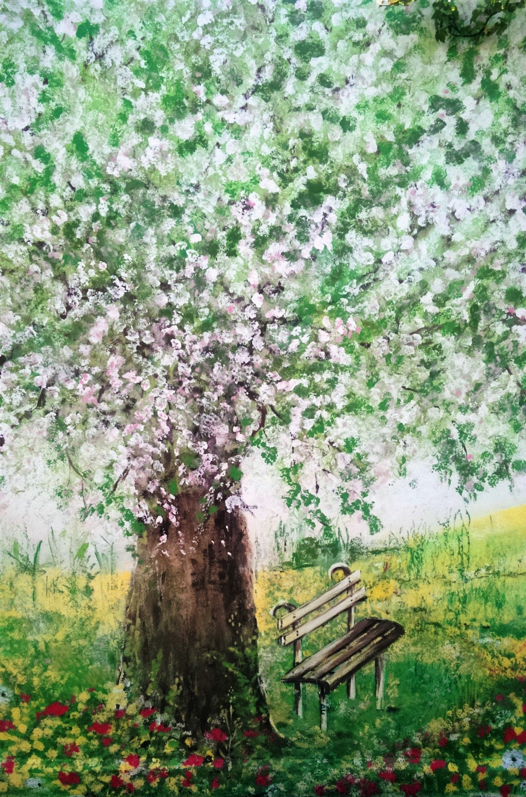

Clondalkin Tús Nua – Back wall Mural

