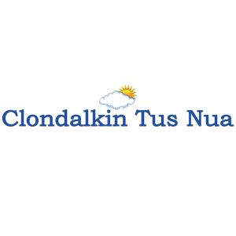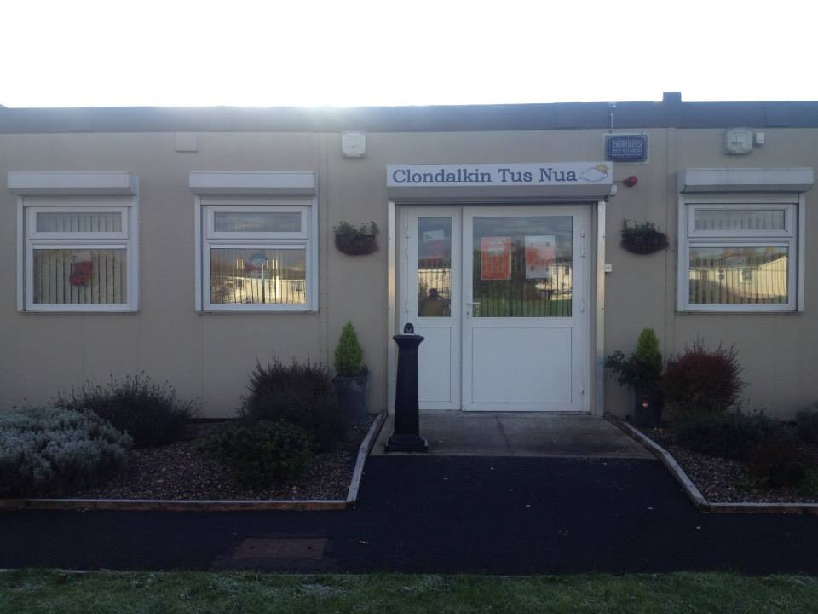
ANNUAL REPORT
2020

New Nangor Road, Clondalkin, Dublin 22
Tel: 01 4572938
Registered Charity Number: 20102586
Charity number: 21283
www.clondalkintusnua.ie

Contents Page

About Us 4

Governance 5

Services provided and outcomes 6

In this year 16

Donations 17

Board of Management - Staff 23

Financial Summary 24

A copy of this report is available on our website www.clondalkintusnua.ie

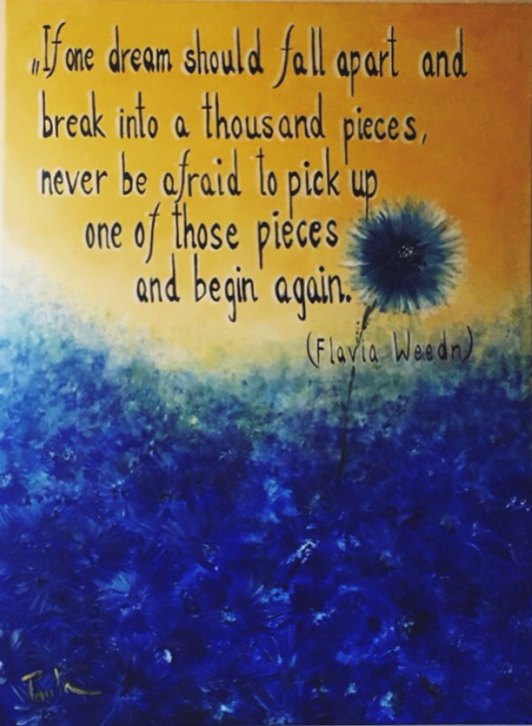

Painting at Reception

About Clondalkin Tús Nua

Clondalkin Tús Nua is a community based addiction support service based in South West Clondalkin, Dublin 22. The project was established in 1996 as a response to the local drug problem. As a community, we sought solutions to the drug problems in the area. This was achieved by developing practical and effective ways of working with statutory agencies and local service providers. Through funding from the Health Service Executive, D.S.P. and the Clondalkin Drugs and Alcohol Task Force. Clondalkin Tús Nua opened in September 1999. The centre is the first port of call for those requiring advice or information on issues of drug use and misuse. To date our centre remains accessible to anyone who wishes to avail of the wide range of services. Using a holistic approach, we endeavour to provide services that cater for the needs of the mind, body and spirit of the service user. These services are delivered in a professional manner that is flexible in a locally based, accessible venue and include Addiction Support, Rehabilitation Day Programme and Family Support.

COVID-19

Clondalkin Tús Nua continued to provide services throughout COVID-19. This was only possible due to the dedication and commitment of our staff teams, who faced huge challenges and done an amazing job in providing continual support to our service users. We adapted our service to ensure that we operated in line with the recommendation made by the HSA/HSE and continually monitored the situation to ensure we provided a safe setting for both staff and service users.
We developed a Service Response Plan to cover us through the five levels of COVID-19, each level containing a set of additional measures. The plan was fluid, reviewed and adapted depending on staff levels and government guidelines.

As a front line organization, our aim was to keep our service open and to continue to provide essential supports to those most vulnerable in our community while at all times prioritising the health and safety of our staff and service users.

It is hoped that this report will give the reader an insight into the service delivered by Clondalkin Tús Nua.
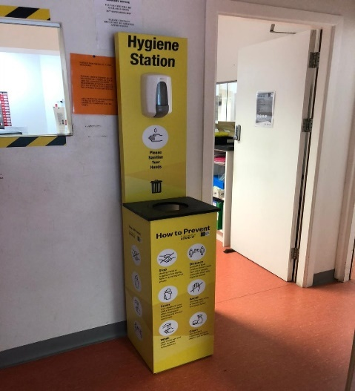

Governance

Clondalkin Tús Nua is a Company Limited by Guarantee and a registered charity. Our organisation receives funding from the HSE Section 39/Clondalkin Drug & Alcohol Task Force, Department of Employment Affairs and Social Protection and TUSLA Family Support Agency. As such there are a number of governance frameworks that our organisation must comply with on an annual basis. The Board of Clondalkin Tús Nua is responsible for overseeing the performance and governance of the organisation. There are several legal, financial and regulatory standards that must be adhered to in order to govern the performance of Clondalkin Tús Nua well. Clondalkin Tús Nua is obliged to provide a return to the Charities Regulatory Authority (CRA), this return outlines how the governance of Clondalkin Tús Nua adheres to the CRA governance code. Clondalkin Tús Nua has demonstrated its compliance with the code by developing a plan to adhere to the principles and has evidence of work towards this plan. This compliance checklist has been completed by the organisation and was signed off on the 2nd of November 2021 at a Clondalkin Tús Nua board meeting.

Services provided by
Clondalkin Tús Nua in 2020
Clondalkin Tús Nua provides a model of treatment and rehabilitation that incorporates a range of actions that promotes a continuum of care across a diverse sector of addiction-based interventions, from a low threshold drop in service to a structured rehabilitation day programme and aftercare service. The aim of this approach is to provide a coordination of services and smooth transition between the different phases of treatment for our client base

Description of Services:

Open access Drop in
- Homeless drop in, Homeless service, incl. shower/laundry facilities (temporarily suspended due to COVID 19)
- Aftercare support
- Education/Therapeutic workshops
- Gender specific programmes
- Complimentary therapies (temporarily suspended due to COVID 19)
- Access to Counselling
- Outreach service/NSP
- Street based harm reduction service
- Rehabilitation Day Programme
- Family Support

Open Access Contact centre
- To engage with clients in addiction
- To provide face to face support to clients in active addiction, stabilised or drug free
- To bring about change in drug use
- To provide supports to those clients wishing to remain drug free
- To provide information and internal/external referral pathways

Outreach/Harm Reduction/NSP Service:
To provide harm reduction supports for service users in the Clondalkin area whom are actively engaging in substance use. Our aim is to promote harm reduction, good health/safe sex practices, information regarding positive choices and move on options. We provide daily NSP outreach/in-reach sessions.
- Outreach-Service/NSP and crack pipe distribution
- Brief Interventions
- Initial Assessments and Support Plans
- Referrals to Support Service
- Health Promotion/Harm Reduction Interventions
- Homeless Interventions/Referrals
- Advocacy Supports

SAFE (Support, Advice, Free Exchange, Empathy)
To provide targeted harm reduction outreach to those using the train line to disembark in Clondalkin to purchase drugs. The Assertive Case Manager will engage with people who are high risk and provide NSP and crack pipe distribution, information and support regarding services in their own areas, conduct assessment of need and provide referral pathways into services in their own locality and support a shared care approach for those most marginalised from services
- SAFE Targeted Outreach-Service/NSP and crack pipe distribution
- Brief Interventions
- Initial Assessments and Support Plans
- Advocacy Supports
- Case Management/Care-Plan Development
- Interagency Collaboration
- Referrals to Support Service Cross County
- Health Promotion/Harm Reduction Interventions
- Homeless Interventions/Referrals
- Information Campaigns

Addiction/Substance Support Services
To provide access to structured one to one sessions and or case management set in a confidential, safe environment.
Sessions could involve any of the following interventions:

- Treatment Planning
- Individual Care plans
- Relapse Prevention
- Crisis Intervention
- Harm Reduction
- Motivational Interviewing
- Referrals to Treatment Centres, Counselling,
- Education/employment
- Referrals to Mental Health Services, Complimentary therapies
- Progression routes to build upon recovery capital
- Aftercare
- Gender Specific Issues
- Initial and Comprehensive Assessments
- Advocacy
- Community Reintegration

Stabilisation services:
One to one addiction support, gender specific group work, pre/post detoxification supports, access to counselling, referrals to rehabilitation/treatment programmes and advocacy
The aim of this action is to provide clients with a comprehensive need’s assessment. To identify and develop a structured care plan that incorporates psychological problems, physical problems, social issues and legal problems

C.T.N. Station 1 Rehabilitation Day Programme:
Unit C1 Station Road Business Park, Station Road, Clondalkin, Dublin 22
The rehabilitation day programme currently runs 5 days per week and provides a diverse and integrative group recovery intervention model. We have developed a tier-based approach to support the individual through the various stages of change and building of recovery capital that is achievable and maintainable.

- P1 Stabilisation Programme/P2 Recovery Preparation
- P3 Drug/Alcohol Free Day Programme
- P4 Progression and Integration Pathways ACE Programme
- P5 Aftercare

Family Support (Concerned Person) Services:
Our Family Support Service provides support to family members (concerned persons over 18) affected by another person’s drug or alcohol use.
This support takes the form of one-to-one sessions, crisis intervention, education/therapeutic workshops, referrals for counselling, group support.
- Open access contact centre
- Information on drug & alcohol addiction
- One to one support
- Group support (temporarily suspended due to COVID 19)
- Peer Support
- Education/Therapeutic workshops
- Access to counselling
- Referrals to additional family and children Services

Clondalkin Tús Nua accommodates:

- Tuesday and Wednesday evening AA Meetings (temporarily suspended due to COVID 19)

- Tuesday evening Al-Anon meetings (temporarily suspended due to COVID 19)

- SDCC Homeless Outreach worker every 2nd Wednesday afternoon during our Drop in Time (temporarily suspended due to COVID 19)

Number of Service Users Availing of the Service

Open Access Contact/Drop in:
- Individual attendances for Drop in Supports: 658
- Homeless Interventions: 90
- Referred to Addiction Support Service: 17
- Referred to Station 1 Rehabilitation Programme: 3
- Referred to Safe Initiative: 5
- Referred to SDCC Homeless outreach worker: 20

Outreach/Harm Reduction/NSP Service:
- Harm Reduction/Brief/Crisis Interventions Sessions: 260
- Number of NSP Provided: 963

SAFE Assertive Case Management Services:
- Service user engaged for Assertive Case Management: 48
- Service user engaged Train Station Outreach: 44
- SAFE caseload: 15
SAFE Brief Interventions & Referral Pathways
- Referred to OST: 46
- Referred to Outreach, Key working/Addiction Supports in service users’ locality: 17
- Referred to Residential Detox: 5
- Referred to Homeless and Housing Supports: 22
- Referred to Medical Card/Advocacy: 7
- Referred to Family Support: 2
- Referred to Counselling: 3

Addiction/Substance use Support Services:
- Number of services users accessing ASS: 134
- One to one sessions Provided: 1066
- Key working Sessions: 850
- Crisis/Brief Interventions: 130
- Assessment/Initial contact Screening: 86

- Referred to Station 1 Rehab programme: 3
- Family Support Services: 6
- Referred to Residential Treatment: 9
- Referred to HSE Addiction services: 5
- Referred to Counselling Service: 5
- Referred to Education/Training programmes: 2
- Referred to Child and Family Services: 4
Incoming Case-management Referrals:
- Referred internally from low Threshold: 19
- Referred into our service from TUSLA: 1
- Referred into our service from Community GP’s: 11
- Referred into our service from Clondalkin Mental Health: 6
- Referred into our service from Probation and Welfare: 3
- Referred by other addiction services: 3

Station 1 Rehabilitation Programme:
Pre programme induction supports: 35
- 11 Service Users referred on to Drug Free Programme
- 5 Service Users referred on to Stabilisation Programme/pre detox supports
- 7 Service Users referred on to P5 aftercare supports.
- 9 Service Users felt treatment was complete after shot-term interventions (4-12weeks)
P1 Stabilisation Programme/P2 Recovery Preparation: 12
Service Users received a mix of supports including referral to residential treatment/detox, community detox, support in applying to Cuan Dara, support whilst awaiting access to St Francis Farm Residential Programme
P3 Drug & Alcohol Free Programme: 21
Outcomes for Service Users included progression into full-time employment, into P4 Progression and Integration Pathways ACE Programme, 3rd level educational courses
P4 Progression and Integration Pathways ACE Programme: 10
Service Users progressed to a mix of full-time employment, 3rd level education and placements in community services.

P5 Aftercare: 12
Service Users accessed aftercare supports in Station 1 this included key working and case management, referrals for additional supports, brief and crisis interventions and counselling.
In house group interventions provided in 2020
- SMART RECOVERY 12-week blocks
- Weekly Therapeutic Peer Process Group
- Straight Ahead Group Recovery Programme
- Reduce the Use Group
- Cognitive Behavioural Skills Group
- Stress Management
- Relapse Prevention Skills Group
- Addiction Awareness Workshops
- Yoga
- Art (1st quarter due to COVID)
- Self-Care and Wellbeing (COVID focused)
- Health and Fitness (1st quarter due to COVID)
- Acupuncture (1st quarter due to COVID)
- Communications Skills QQI L3 (1st quarter due to COVID)
- Literacy Group (1st quarter due to COVID)
- Computer Skills how to use ZOOM/ Online Platforms

Family Support:
- Individual Family Support Interventions: 290
- Crisis Interventions: 28
- Individual availed of one-to-one support sessions: 72
- New services users: 40
- Family Support Group attendance: 96 (Jan to March) (Due to COVID 19 restrictions and health & safety this service is being provided on an individual basis)
- In house Family Support Group Interventions provided in 2020
- Wednesday Evening Family Support Group (1st quarter due to COVID)
- Tuesday Morning Family Support Group (1st quarter due to COVID)

Station 1 - Rehabilitation Day Programme

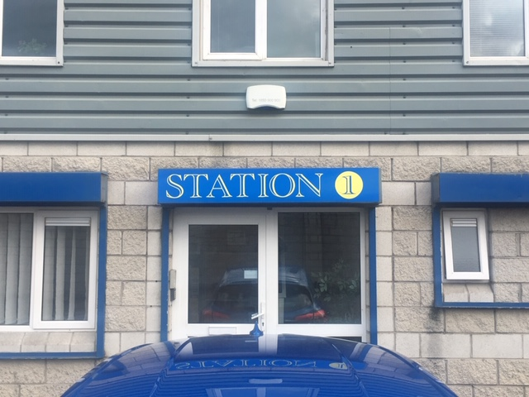

In 2006, Clondalkin Tús Nua highlighted the lack of locally based CE Rehabilitation places suitable for drug users in the early stages of recovery. Responsibility was given to Clondalkin Tús Nua and Clondalkin Drug Task Force Treatment & Rehabilitation Sub-Group to develop a proposal for a community based Rehabilitation Project.
In December 2007, Clondalkin Tús Nua launched Station 1 Rehabilitation & Development Programme.
Station 1 is a D.S.P. sponsored rehabilitation day programme, tailored to meet the needs of individuals in recovery from substance dependency.
Our aim is to provide a therapeutic setting to focus on returning to work and gaining economic/social independence, while providing a continuum of support in relation to recovery needs.
The main elements of the programme are Education, Holistic and Therapeutic
- 2 x 19.5 hours per week of which 16 hours are delivered on a group basis

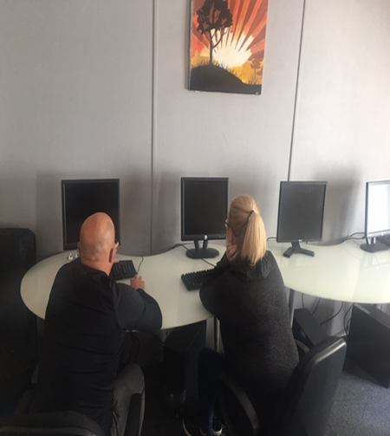
Education:
Our Educational Interventions are based on:
- Providing a learning environment that is interactive, collaborative and enjoyable.
- Providing material that is relevant to the needs of the participant group.
- Neutralising any negative associations from previous learning environments

Holistic:
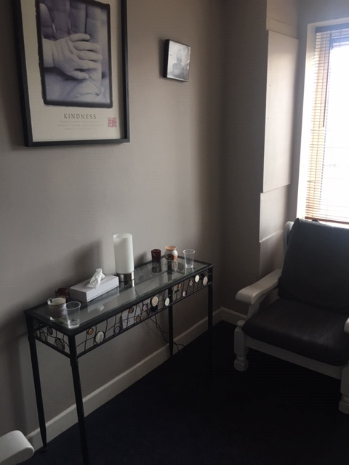
- Encouraging the participant to include healing strategies that support the whole person.
- Providing tools that help and increase control over one's behaviour in positive ways.
- Reducing tension, anxiety, depression and insomnia. Improving overall mental and physical wellbeing.

Therapeutic:
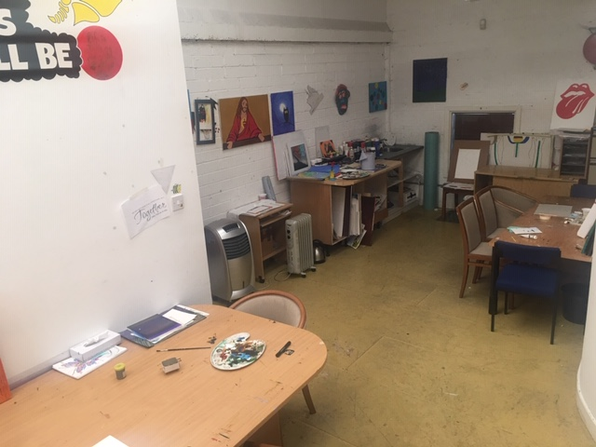

- Providing a core concept form that feeds into all elements of the programme.
- Providing group setting in which participants can gain a deeper understanding of the process of addiction.
- Providing and promoting a peer support setting to enable participants to relate with each other in a caring and supportive way.

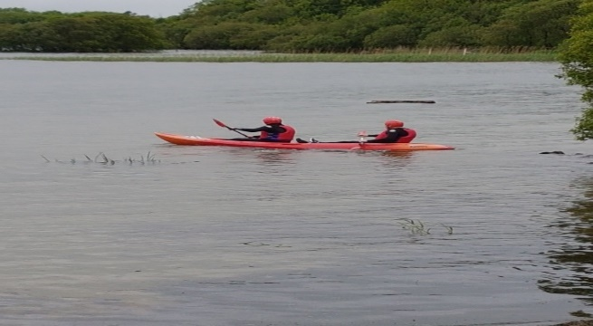

Family Support

Family Support is an integral tenant of the service our project provides. This support takes the form of one to one sessions, crisis intervention, education/therapeutic workshops, referrals for counselling, group support, and much more. It is implicit through the amount of work we do in this area that Family Support remains a vital resource of our project’s holistic approach to the challenge addiction represents in our community.
Through one to one sessions, the Family Support Worker is able to assess and identify the individual family member’s needs, develop a specific care plan and implement the supports needed. This is the most personal way in which we can address our family’s needs.

With the Wednesday night and Tuesday morning Family Support Groups we foster peer support from within the community and help family members develop crucial networks of peer support and friendship which help to minimise the feelings of isolation and self-blame which are so common around addiction in the family.

- Open access Contact centre
- One to One Support

In this year

Due to Covid 19 restrictions only 1 of our usual annual events took place in this year. This event was Women’s International Day and took place on the 8th March 2020

79 Women attended for:

- Relaxing Therapies

- Nails and beauty treatments

- Group meditation

- Lunch

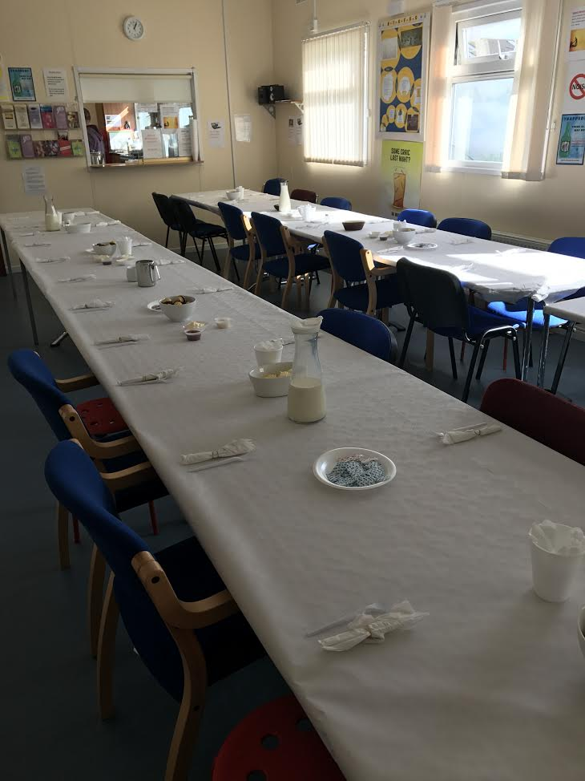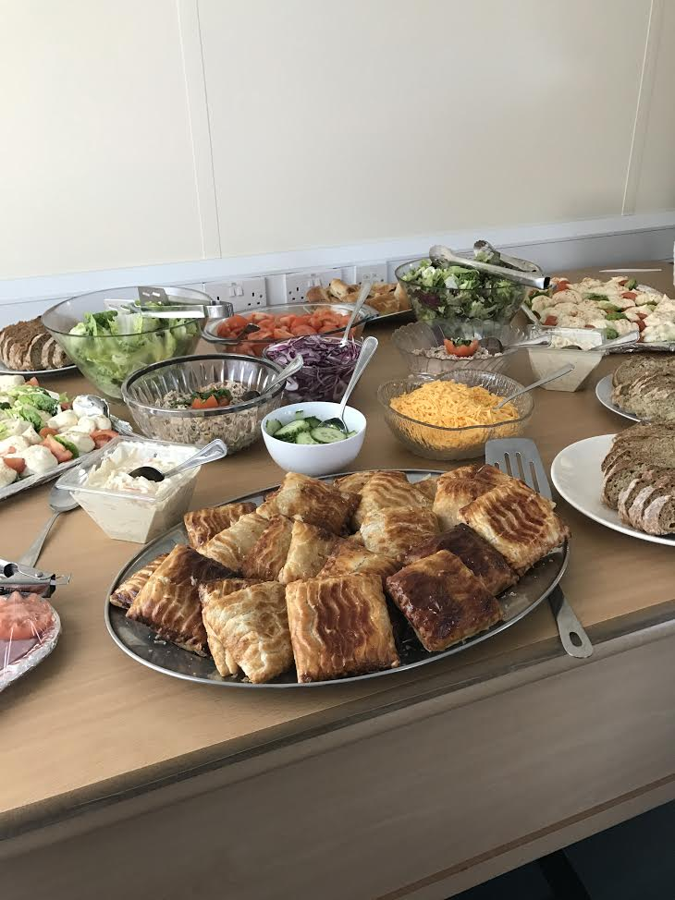

In 2020 the project continued to receive huge amounts of donations of food, new clothing, tents, sleeping bags etc.

DONATIONS OF FOOD FOR DISTRIBUTION TO NEEDY FAMALIES IN OUR AREA

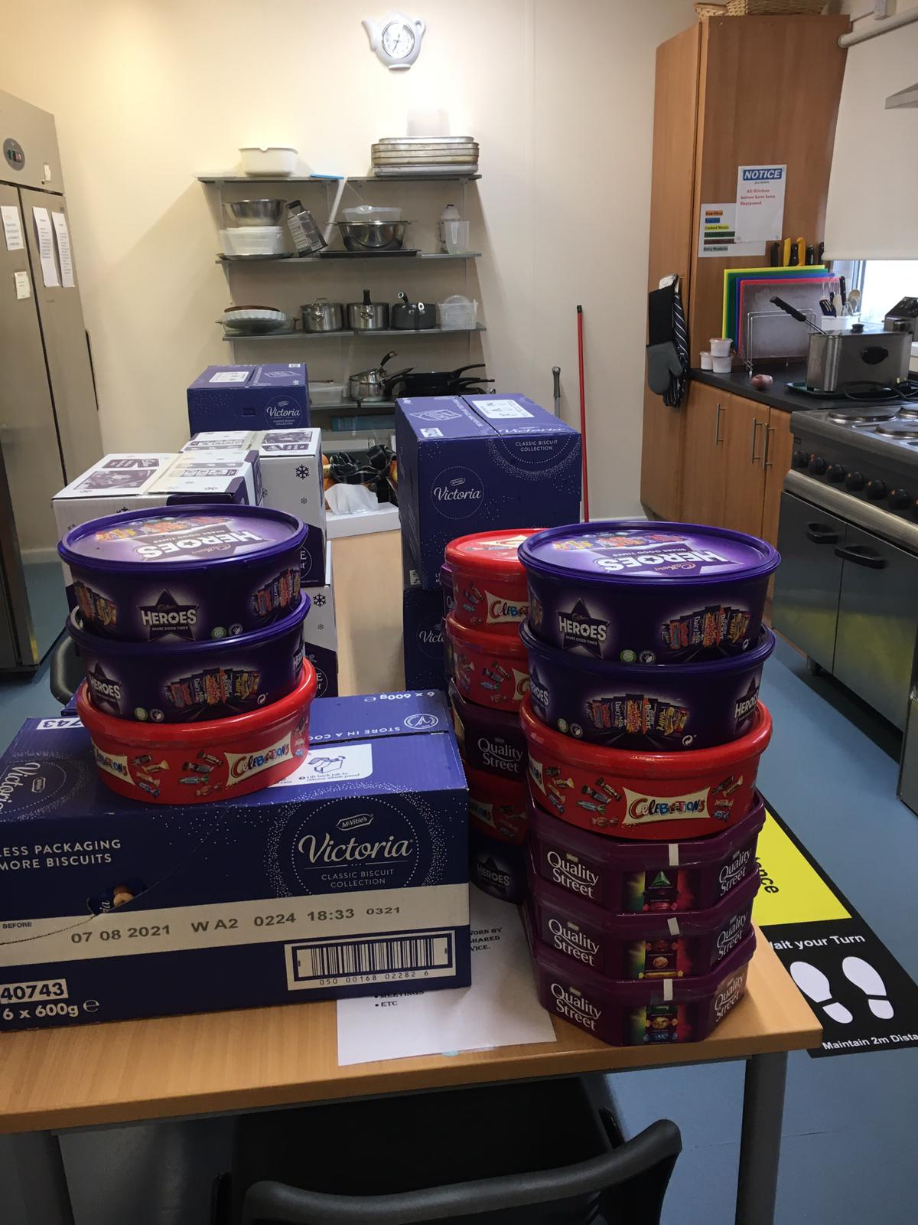

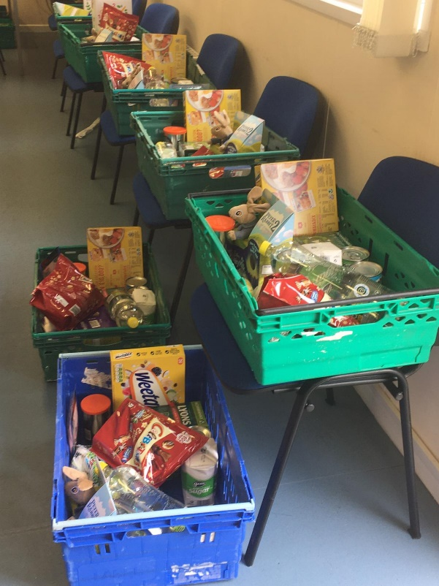

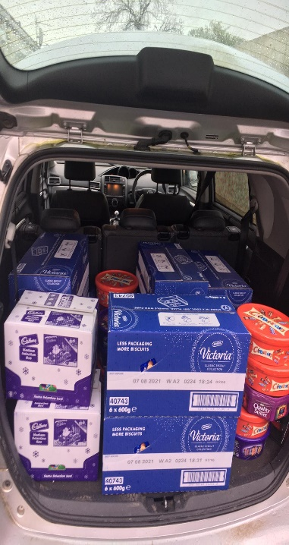
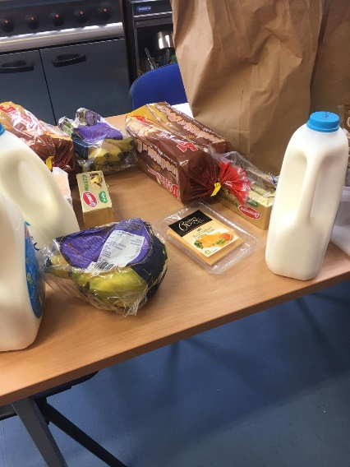

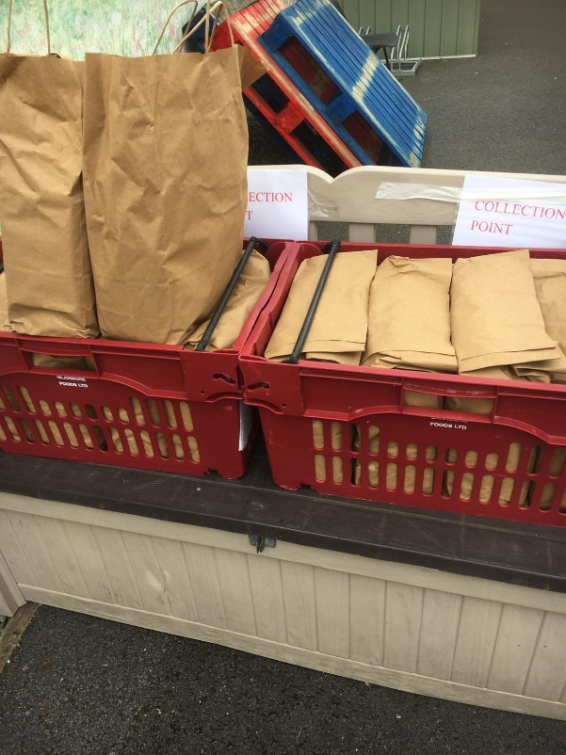

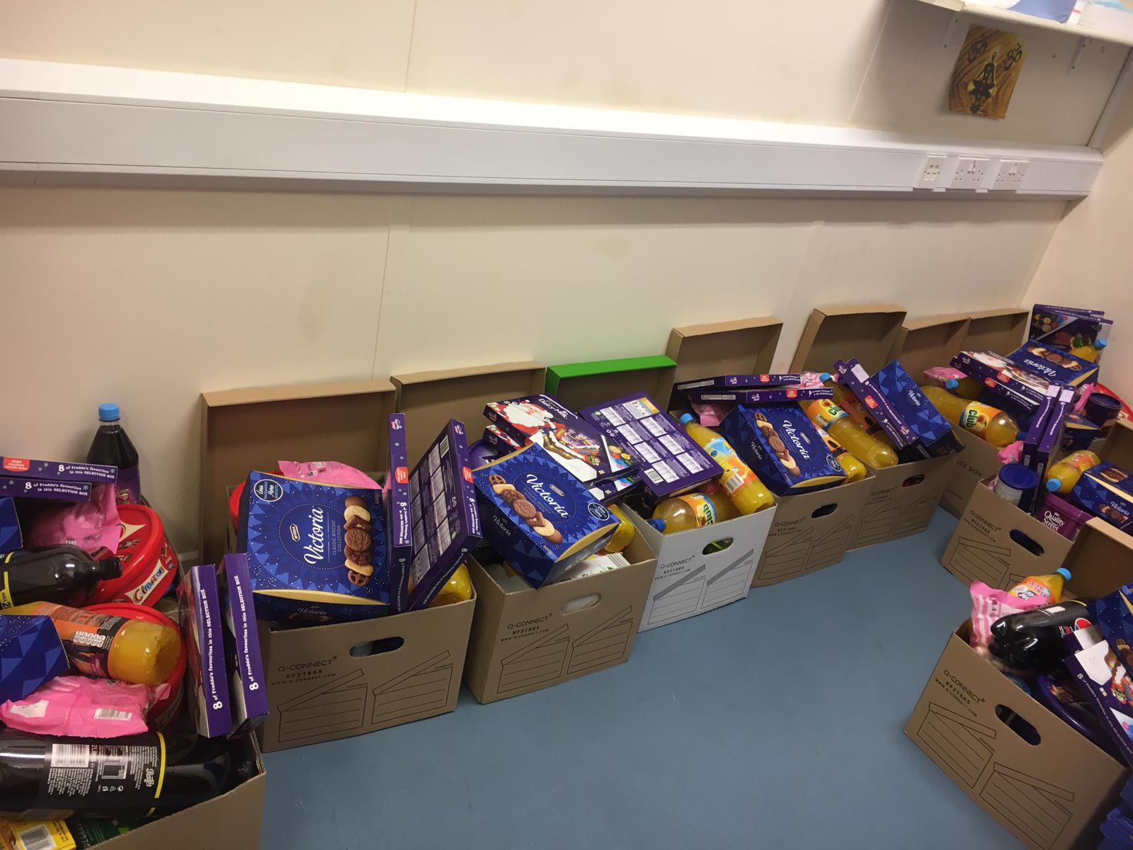

DONATIONS OF CLOTHING/SLEEPING BAGS/TENTS ETC. FOR THE ROUGH SLEEPERS IN OUR AREA

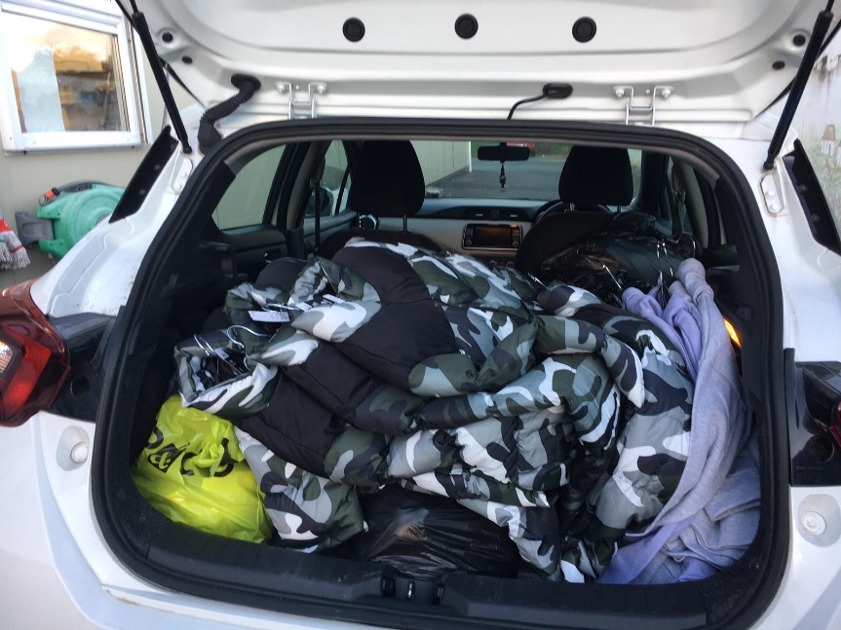

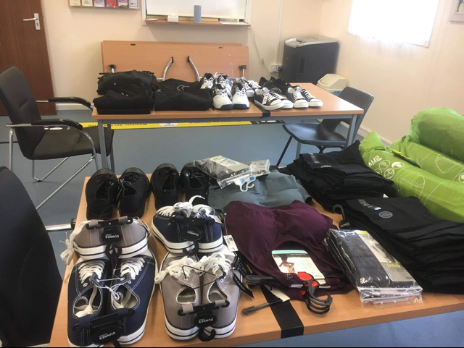

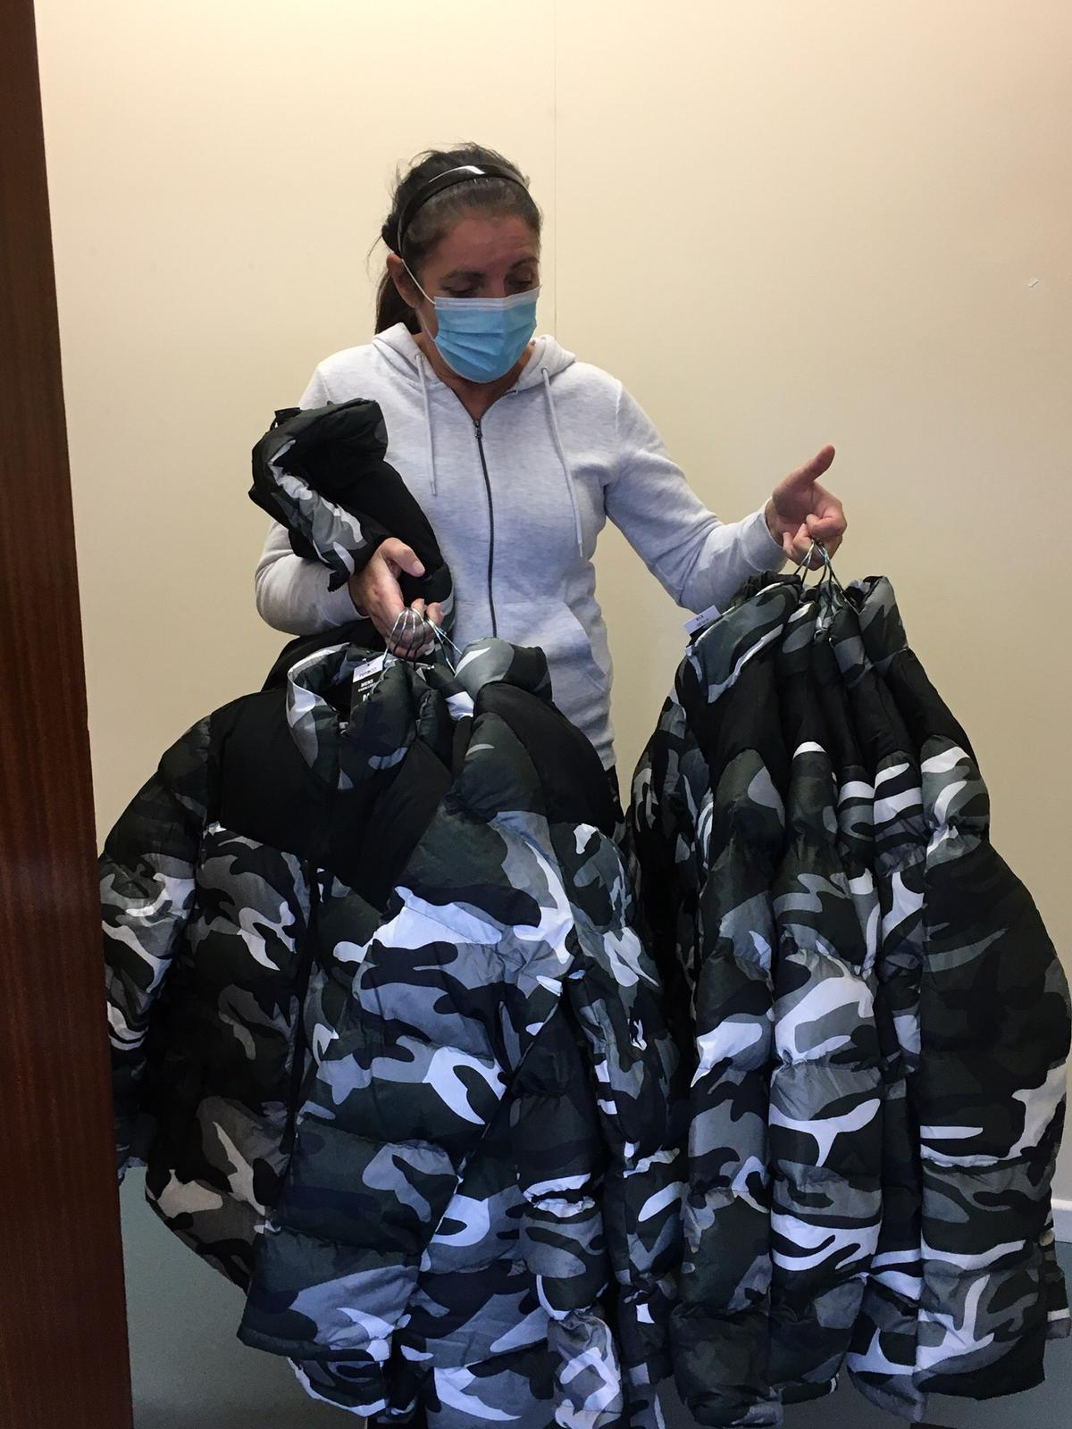

On behalf of Management, staff and Volunteers at Clondalkin Tús Nua, we would like to take this opportunity to thank you all.

Board of Management and Staff Group

Board of Management
Brian Scanlan
Kathleen O’Sullivan (Treasurer)
Judith Edmunds
Jamie Doran (Chairperson)
Margaret Lawlor
Lisa Kinsella Coleman

Clondalkin Tús Nua:
1 Project Manager
1 Community Employment Supervisor
1 Community Employment Assistant Supervisor
2 Key workers
1 Family Support Worker
1 Outreach Worker
1 Assertive Case Manager
9 C.E. participants
1 Tus participant

Clondalkin Tús Nua - Station 1 Rehabilitation Day programme:
1 Rehabilitation Coordinator
1 Community Employment Supervisor/key worker
1 Community Employment Assistant Supervisor/key worker
1 Project Worker
2 C.E. Support Workers
27 C.E. Rehabilitation Participants
Funding sources
HSE Section 39 / Clondalkin Drug & Alcohol Task Force
Once off grants Clondalkin Drug & Alcohol Task Force
Department of Social Protection
TUSLA Family Support Agency
Financial Summary
Clondalkin Tús Nua have completed our financial audit for 2020 and the following extract was taken from the Director’s report and Financial Statements for the year ended 31st December 2020 and approved by the Board on the 24th August 2021

2020 2019

Income
Donations | 13,392 |  | 35,909
Department of Social Protection | 480,322 |  | 544,023
LDTF - Treatment & Rehabilitation | 249,311 |  | 249,311
LDTF - Prevention Programme | 71,066 |  | 71,086
HSE | 121,796 |  | 121,796
CDTF Once Off Income | 7,030 |  | 6,542
TUSLA | 6,700 |  | 6,700
Safe Program Strand | 60,000 |  | 40,000
Other income | 3,794 |  | -
 | ─────── |  | ───────
 | 1,013,411 |  | 1,075,367
 | ─────── |  | ───────

Expenditure
Materials | 4,124 |  | 6,062
Wages and salaries | 781,603 |  | 802,118
Social welfare costs | 51,573 |  | 47,924
Staff/ Participants Training | 10,194 |  | 9,253
Drop In Costs | 1,969 |  | 3,078
Once Off Funding | 5,884 |  | 4,925
Rent payable | 20,000 |  | 20,000
Insurance | 19,490 |  | 20,338
Equipment Costs | 9,772 |  | 6,975
Light and heat | 10,193 |  | 13,342
Aras - Safe Programme | - |  | 13,155
Repairs and maintenance | 9,604 |  | 13,317
Printing, postage and stationery | 7,147 |  | 4,447
Telephone | 6,443 |  | 4,966
Computer costs | 5,613 |  | 2,077
Tusla - Parent Support Counselling | 5,313 |  | 5,425
Legal and professional | - |  | 485
Rehabilitation Programme Costs | 7,450 |  | 11,499
Bank charges | 748 |  | 907
Donations/ Fundraising | 7,838 |  | -
General expenses | 3,896 |  | 6,581

Auditor's remuneration | 6,315 |  | 6,335
Depreciation | 35,048 |  | 45,461
 | ─────── |  | ───────
 | 1,010,217 |  | 1,048,670
 | ─────── |  | ───────

Finance
Other interest | 1,579 |  | 2,548
 | ─────── |  | ───────

Net surplus | 1,615 |  | 24,149
 | ═══════ |  | ═══════

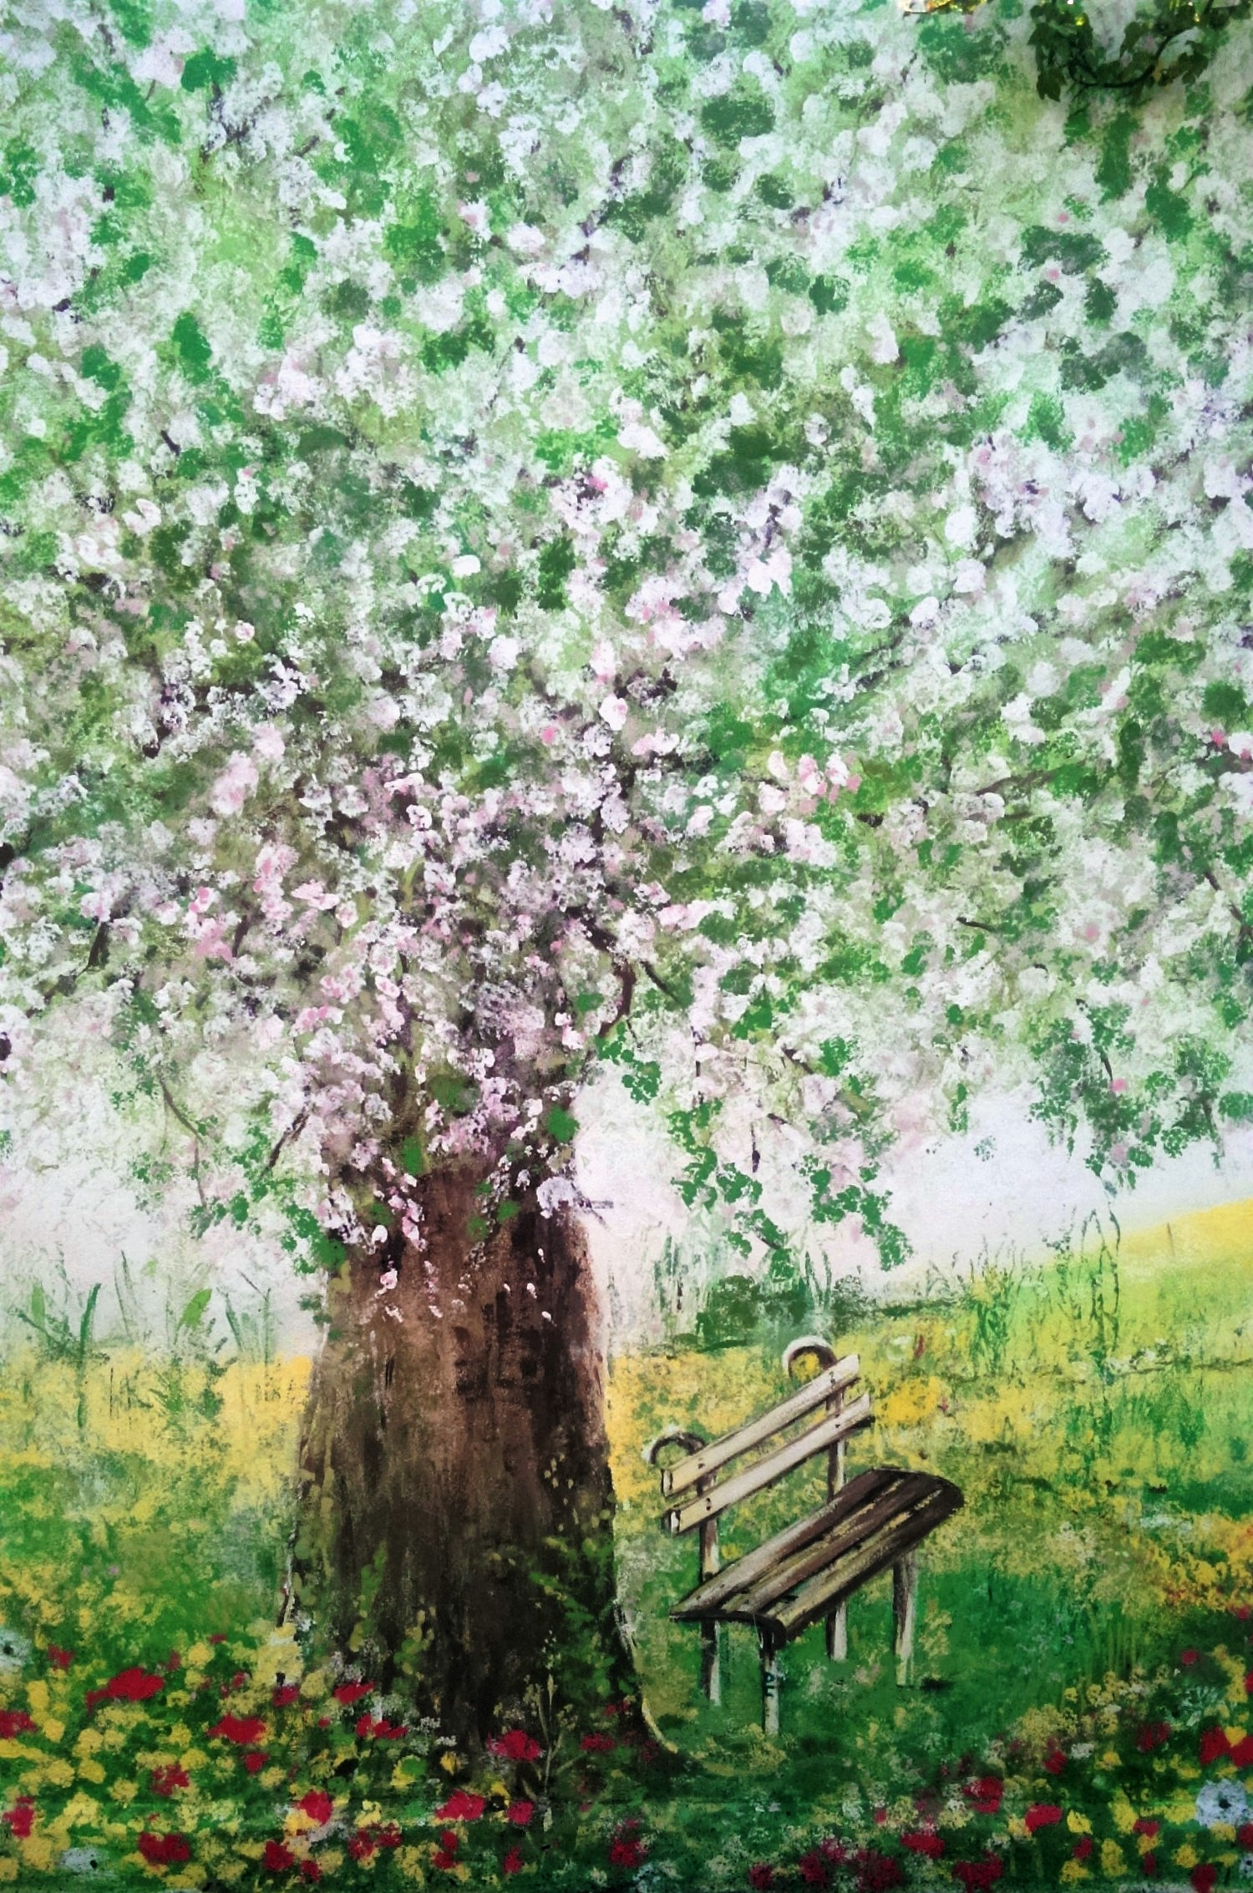

Clondalkin Tús Nua – Back wall Mural

