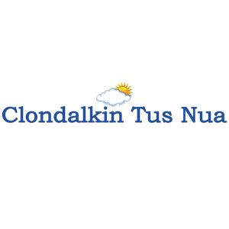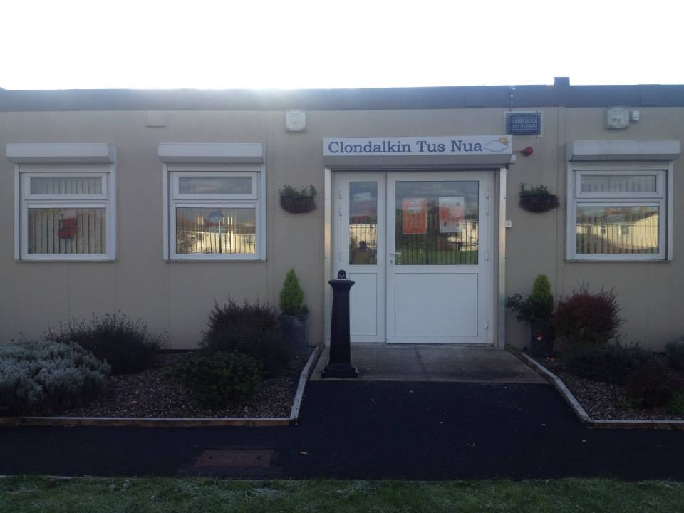
ANNUAL REPORT
2022

New Nangor Road, Clondalkin, Dublin 22
Tel: 01 4572938
Registered Charity Number: 20102586
Charity number: 21283
www.clondalkintusnua.ie

Contents Page

About Us 4

Governance 5

Services provided and outcomes 6

In this year 16

Donations 18

Organisation chart 20

Board of Management - Staff 21

Financial Summary 22

A copy of this report is available on our website www.clondalkintusnua.ie

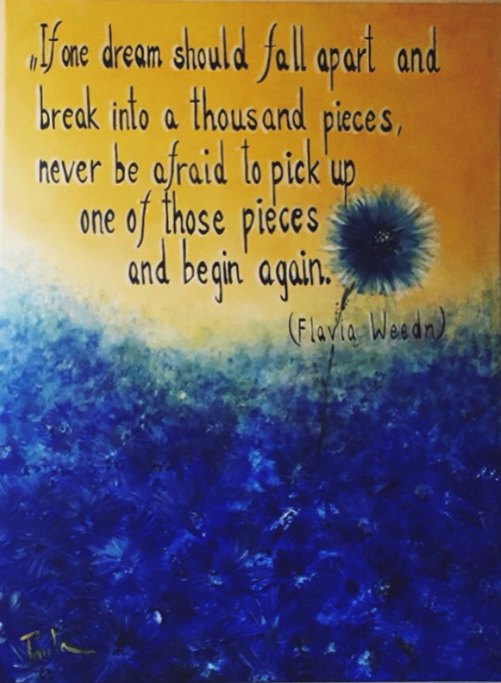

Painting at Reception

About Clondalkin Tús Nua

Clondalkin Tús Nua is a community based addiction support service based in South West Clondalkin, Dublin 22. The project was established in 1996 as a response to the local drug problem. As a community, we sought solutions to the drug problems in the area. This was achieved by developing practical and effective ways of working with statutory agencies and local service providers. Through funding from the Health Service Executive, D.S.P. and the Clondalkin Drugs and Alcohol Task Force. Clondalkin Tús Nua opened in September 1999. The centre is the first port of call for those requiring advice or information on issues of drug use and misuse. To date our centre remains accessible to anyone who wishes to avail of the wide range of services. Using a holistic approach, we endeavour to provide services that cater for the needs of the mind, body and spirit of the service user. These services are delivered in a professional manner that is flexible in a locally based, accessible venue and include Addiction Support, Rehabilitation Day Programme and Family Support.

It is hoped that this report will give the reader an insight into the service delivered by Clondalkin Tús Nua.

Governance

Clondalkin Tús Nua is a Company Limited by Guarantee and a registered charity. Our organisation receives funding from the HSE Section 39/Clondalkin Drug & Alcohol Task Force, Department of Employment Affairs and Social Protection and TUSLA Family Support Agency. As such there are a number of governance frameworks that our organisation must comply with on an annual basis. The Board of Clondalkin Tús Nua is responsible for overseeing the performance and governance of the organisation. There are several legal, financial and regulatory standards that must be adhered to in order to govern the performance of Clondalkin Tús Nua well. Clondalkin Tús Nua is obliged to provide a return to the Charities Regulatory Authority (CRA), this return outlines how the governance of Clondalkin Tús Nua adheres to the CRA governance code. Clondalkin Tús Nua has demonstrated its compliance with the code by developing a plan to adhere to the principles and has evidence of work towards this plan. This compliance checklist has been completed by the organisation and was signed off on the 13th of December 2022 at a board meeting of Clondalkin Tús Nua.

Services provided by
Clondalkin Tús Nua in 2022

Clondalkin Tús Nua provides a model of treatment and rehabilitation that incorporates a range of actions that promotes a continuum of care across a diverse sector of addiction-based interventions, from a low threshold drop in service to a structured rehabilitation day programme and aftercare service. The aim of this approach is to provide a coordination of services and smooth transition between the different phases of treatment for our client base

Addiction/Substance Support Services
To provide access to structured one to one sessions and or case management set in a confidential, safe environment.
Sessions could involve any of the following interventions:
- Treatment Planning
- Individual Care plans
- Relapse Prevention
- Crisis Intervention
- Harm Reduction
- Motivational Interviewing
- Referrals to Treatment Centres, Counselling,
- Education/employment
- Referrals to Mental Health Services, Complimentary therapies
- Progression routes to build upon recovery capital
- Aftercare
- Gender Specific Issues
- Initial and Comprehensive Assessments
- Advocacy
- Community Reintegration

Stabilisation services:
One to one addiction support, gender specific group work, pre/post detoxification supports, access to counselling, referrals to rehabilitation/treatment programmes and advocacy
The aim of this action is to provide clients with a comprehensive need’s assessment. To identify and develop a structured care plan that incorporates psychological problems, physical problems, social issues and legal problems

C.T.N. Station 1 Rehabilitation Day Programme:
Unit C1 Station Road Business Park, Station Road, Clondalkin, Dublin 22
The rehabilitation day programme currently runs 5 days per week and provides a diverse and integrative group recovery intervention model. We have developed a tier-based approach to support the individual through the various stages of change and building of recovery capital that is achievable and maintainable.

- P1 Stabilisation Programme/P2 Recovery Preparation
- P3 Drug/Alcohol Free Day Programme
- P4 Progression and Integration Pathways ACE Programme
- P5 Aftercare

SAFE (Support, Advice, Free Exchange, Empathy)
To provide targeted harm reduction outreach to those using the train line to disembark in Clondalkin to purchase drugs. The Assertive Case Manager will engage with people who are high risk and provide NSP and crack pipe distribution, information and support regarding services in their own areas, conduct assessment of need and provide referral pathways into services in their own locality and support a shared care approach for those most marginalised from services
- SAFE Targeted Outreach-Service/NSP and crack pipe distribution
- Brief Interventions
- Initial Assessments and Support Plans
- Advocacy Supports
- Case Management/Care-Plan Development
- Interagency Collaboration
- Referrals to Support Service Cross County
- Health Promotion/Harm Reduction Interventions
- Homeless Interventions/Referrals
- Information Campaigns

Family Support (Concerned Person) Services:
Our Family Support Service provides support to family members (concerned persons over 18) affected by another person’s drug or alcohol use.
This support takes the form of one-to-one sessions, crisis intervention, education/therapeutic workshops, referrals for counselling, group support.
- Open access contact centre
- Information on drug & alcohol addiction
- One to one support
- Group support
- Peer Support
- Education/Therapeutic workshops
- Access to counselling
- Referrals to additional family and children Services

We also provide complimentary therapies to Service users including:
- Reike
- Auricular Acupuncture
- Indian head Massage

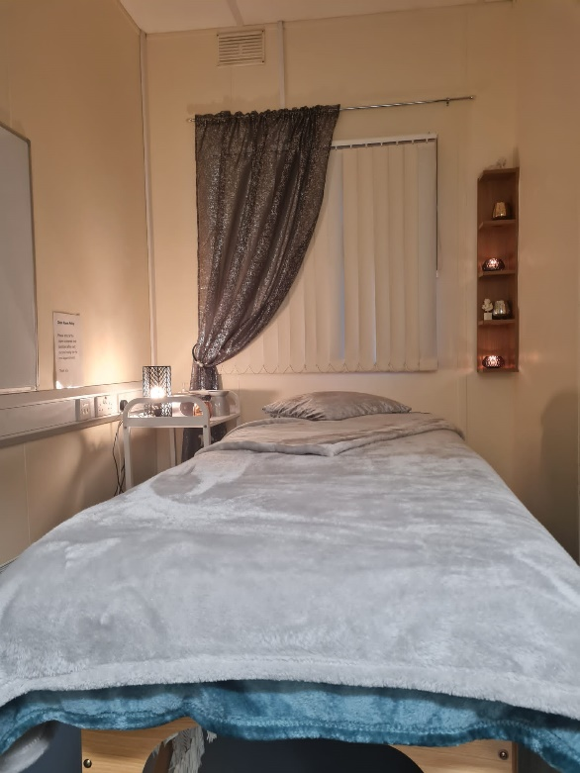

No. of Service Users Availing of the Service in 2022

Open Access Contact /Drop In:
- Individual attendances for Drop in Supports: 693

Homeless Provisions:

- Tent’s 27
- Sleeping bags 356
- Clothes 68
- Food (small food bags) 321
- Food hampers 154

Outreach / Harm Reduction / NSP Service:
- Harm Reduction/ Brief/Crisis Interventions Sessions: 187

NSP Provided: 505
- Foil 34
- Needle packs 271
- Crack pipes 200

Addiction / Substance Use Support Services
Service users accessing Assessment: 164
- One to One sessions Provided: 1147
- Key working Sessions: 679
- Crisis / Brief Interventions: 304
- Assessment / Initial contact Screening:164
- Phone/ Zoom interventions: 91

Station 1 Rehabilitation Programme:
- Service Users Availed of Services in Station 1 Rehabilitation Programme: 48

- Pre programme induction supports: 36
- Service Users referred on to Drug Free Programme:5
- Service Users referred on to Stabilisation Programme / pre detox supports: 17

- Service Users referred on to P5 aftercare support: 4
- Service Users felt treatment was complete after short-term interventions (4-12weeks): 13
- Service Users ceased contact and follow up could not be arranged: 10

P2 Recovery Preparation: 6
- Service Users were referred to residential treatment / detox: 2
- Service Users currently working on referral for Tier 4: 1
- Service User community detox: 0
- Service Users were referred to P3 Drug Free Programme: 3

P3 Drug & Alcohol Free Programme: 14
- Service Users progressed into full-time employment: 3
- Participant progressed to educational programme: 0
- Service Users progressed onto P4 Progression and Integration Pathways ACE Programme: 0
- Service Users attending part-time 3rd level educational courses in addiction: 4

P4 Progression and Integration Pathways ACE Programme: 1
- Service Users progressed to employment: 4
- Service User have moved to mainstream community employment: 1
- Service Users have gained part-time employment: 5

P5 Aftercare: 6
- Service Users accessed aftercare supports in Station 1 this included key one to one, referrals for additional supports, brief and crisis interventions, counselling and evening group meditation: 6

In house group interventions provided in 2022
- Weekly Therapeutic Peer Process Group
- Straight Ahead Group Recovery Programme
- Building Recovery Skills
- Reduce the Use Group
- Cognitive Behavioural Skills Group
- Stress Management
- Aromatherapy
- Crafts workshops
- Meditation
- Relapse Prevention Skills Group
- Addiction Awareness Workshops
- Yoga
- Art
- Self-Care and Wellbeing
- Life Skills and Social Development

Family Support:
- Individual Family Support One to One Interventions: 205
- Crisis Interventions: 28
- Individual availed of one to one support sessions: 61
- New services users: 33
- Family Support Group attendance: 258

Counselling:

- One to One Counselling Sessions: 212

Station 1 - Rehabilitation Day Programme

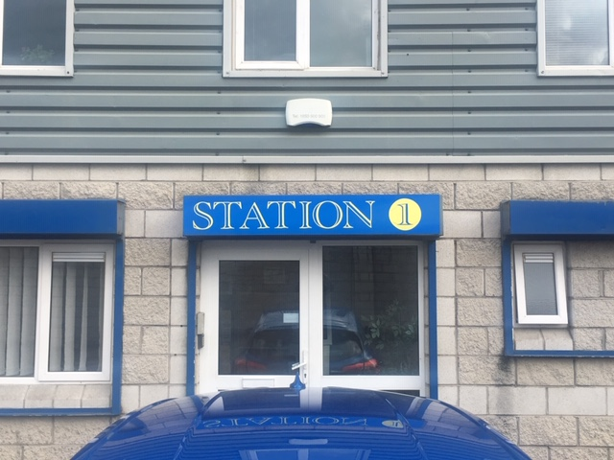

In 2006, Clondalkin Tús Nua highlighted the lack of locally based CE Rehabilitation places suitable for drug users in the early stages of recovery. Responsibility was given to Clondalkin Tús Nua and Clondalkin Drug Task Force Treatment & Rehabilitation Sub-Group to develop a proposal for a community based Rehabilitation Project.
In December 2007, Clondalkin Tús Nua launched Station 1 Rehabilitation & Development Programme.
Station 1 is a D.S.P. sponsored rehabilitation day programme, tailored to meet the needs of individuals in recovery from substance dependency.
Our aim is to provide a therapeutic setting to focus on returning to work and gaining economic/social independence, while providing a continuum of support in relation to recovery needs.
The main elements of the programme are Education, Holistic and Therapeutic
- 2 x 19.5 hours per week of which 16 hours are delivered on a group basis

Education:
Our Educational Interventions are based on:
- Providing a learning environment that is interactive, collaborative and enjoyable.
- Providing material that is relevant to the needs of the participant group.
- Neutralising any negative associations from previous learning environments

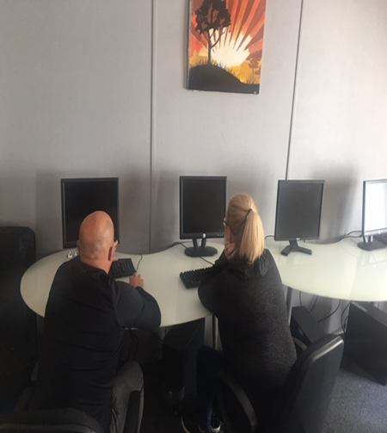

Holistic:
- Encouraging the participant to include healing strategies that support the whole person.
- Providing tools that help and increase control over one's behaviour in positive ways.
- Reducing tension, anxiety, depression and insomnia. Improving overall mental and physical wellbeing.

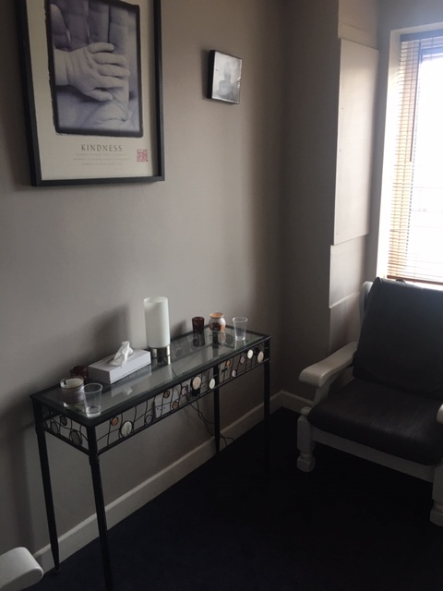

Therapeutic:
Providing a core concept form that feeds into all elements of the programme.
- Providing group setting in which participants can gain a deeper understanding of the process of addiction.
- Providing and promoting a peer support setting to enable participants to relate with each other in a caring and supportive way.

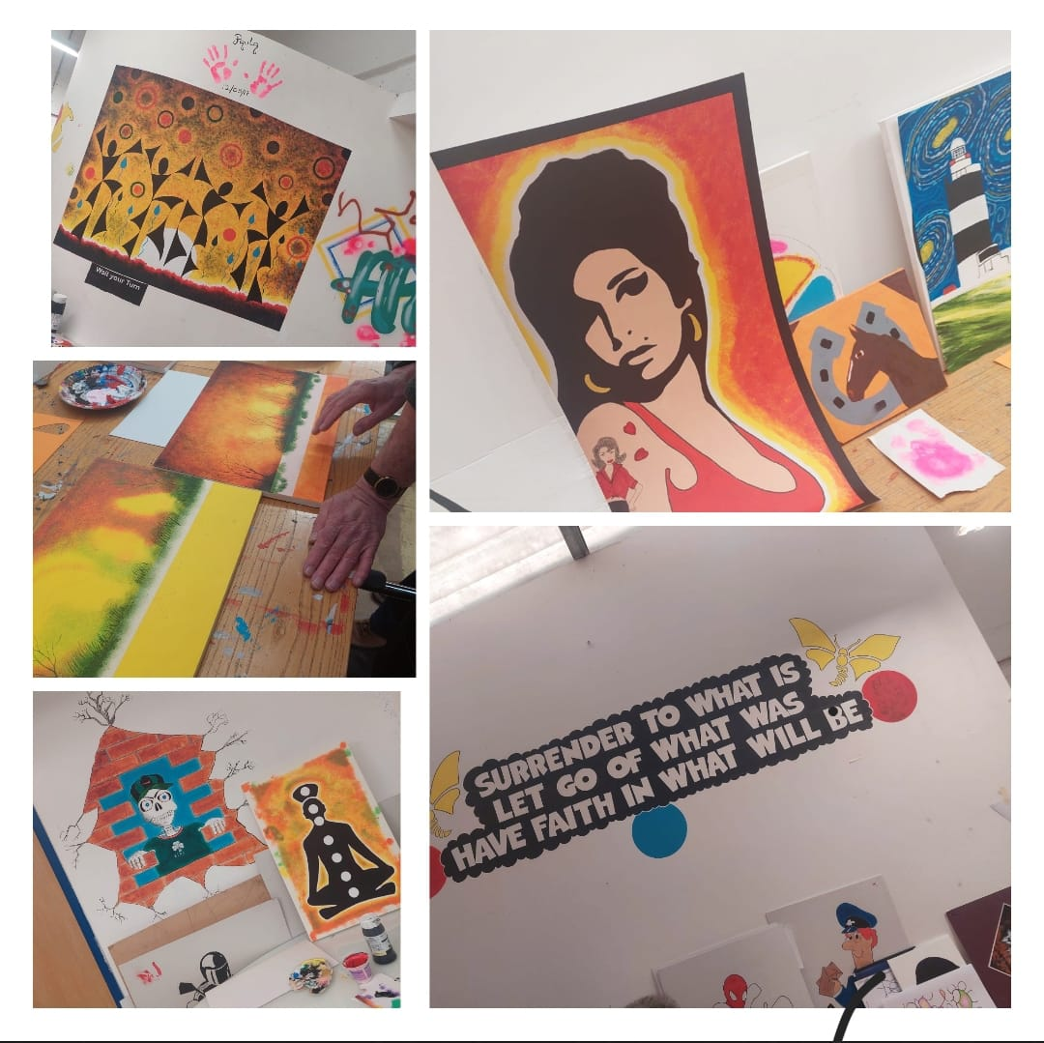

Family Support

Family Support is an integral tenant of the service our project provides. This support takes the form of one to one sessions, crisis intervention, education/therapeutic workshops, referrals for counselling, group support, and much more. It is implicit through the amount of work we do in this area that Family Support remains a vital resource of our project’s holistic approach to the challenge addiction represents in our community.
Through one to one sessions, the Family Support Worker is able to assess and identify the individual family member’s needs, develop a specific care plan and implement the supports needed. This is the most personal way in which we can address our family’s needs.

With the Wednesday night and Tuesday morning Family Support Groups we foster peer support from within the community and help family members develop crucial networks of peer support and friendship which help to minimise the feelings of isolation and self-blame which are so common around addiction in the family.

- Open access Contact centre
- One to One Support

Clondalkin Tús Nua accommodates:

- Tuesday evening AA Meetings

- Tuesday evening Al-Anon meetings

- Wednesday evening CA women’s group

- YDAP

- SDCC Homeless Outreach worker every 2nd Wednesday afternoon during our Drop in Time

In this year

Clondalkin Recovery Choir was formed

- The Clondalkin Recovery Choir is an initiative of the Clondalkin Drug and Alcohol Task Force. With the help and support of the Task Force the choir has developed, with many staff and service users from Clondalkin Tus Nua involved.

The choir meet every Tuesday evenings for rehearsals at our Station 1 premises, Station Road Business Park, Clondalkin Dublin 22

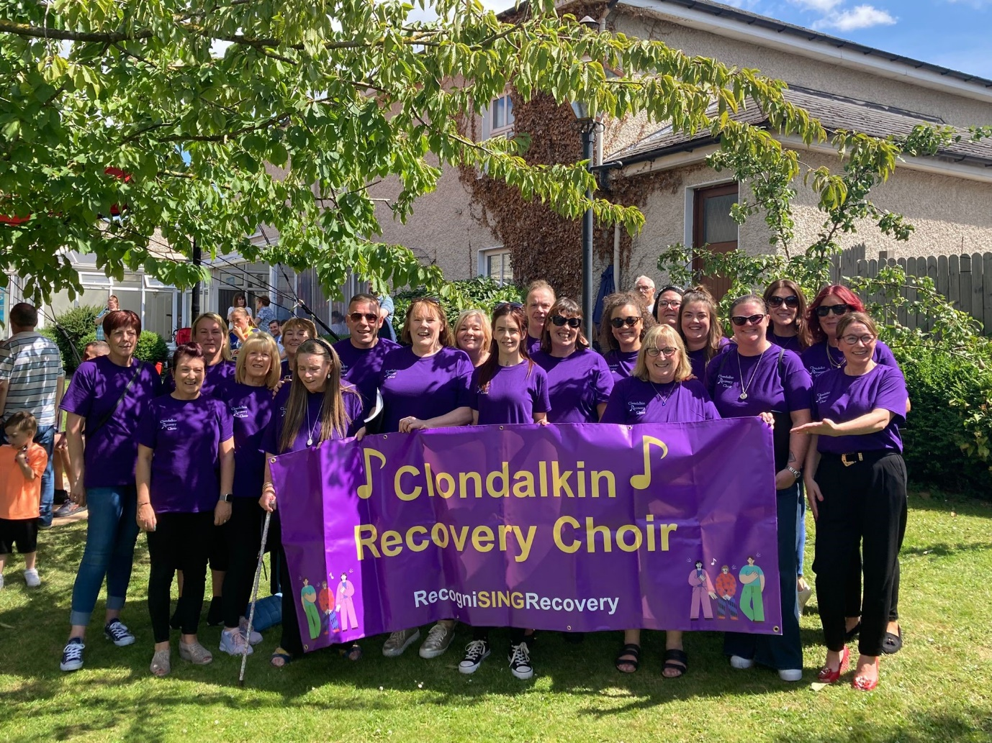

Minsters visit to the project
- In April 2022 the project had a visit from Minister Frank Feighan and representatives from the HSE addiction services and Clondalkin Drug & Alcohol Task Force. It was an opportunity for the representatives to meet with various service user groups.

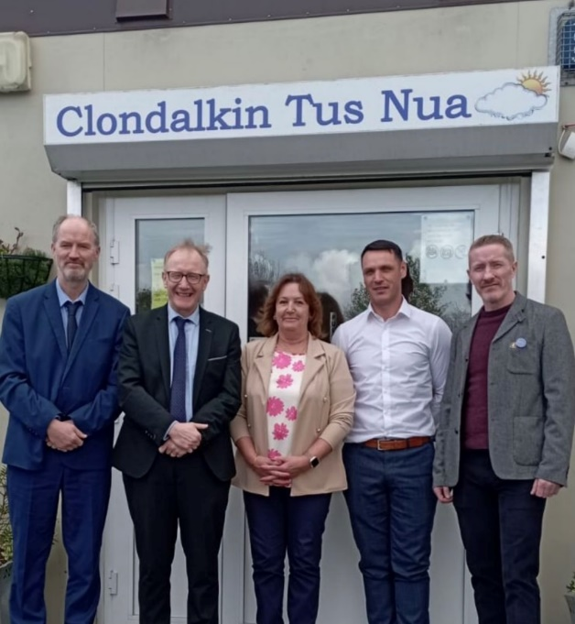

Overdose and Naloxone Training

Staff received training on Overdose and Naloxone from members at UISCE

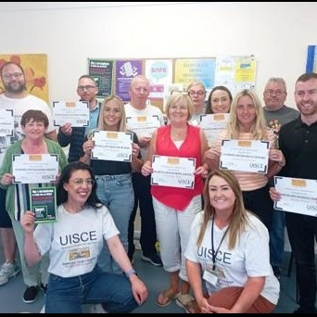
In 2022 the project continued to receive huge amounts of donations of food, new clothing, tents, sleeping bags etc.

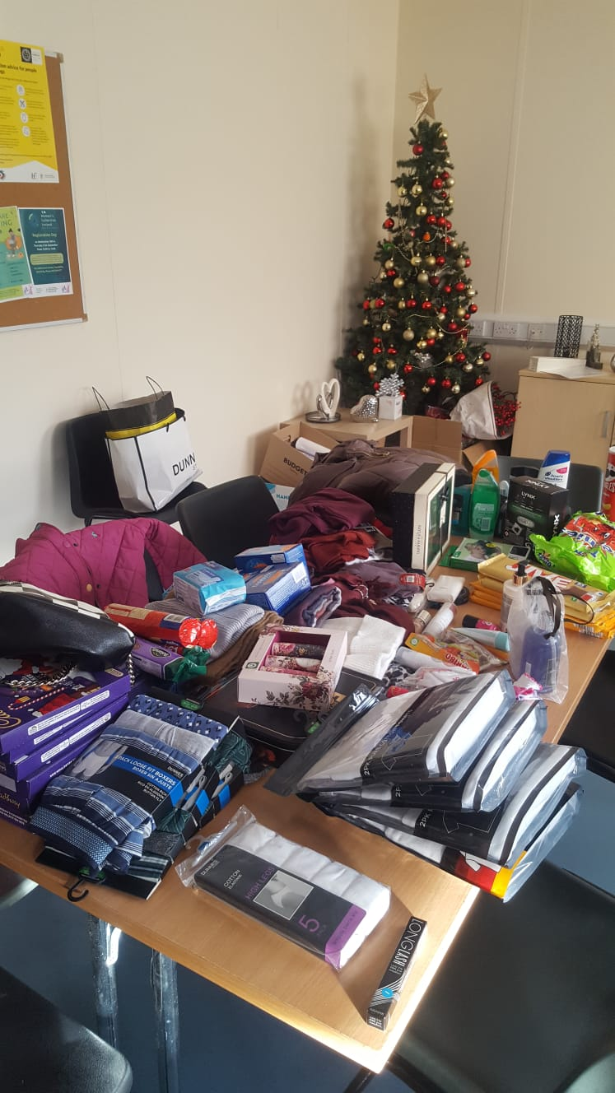

Donations of food for distributions to needy families

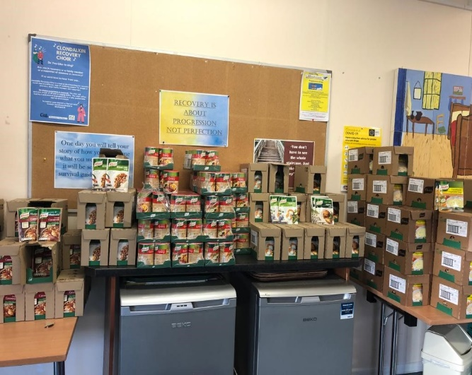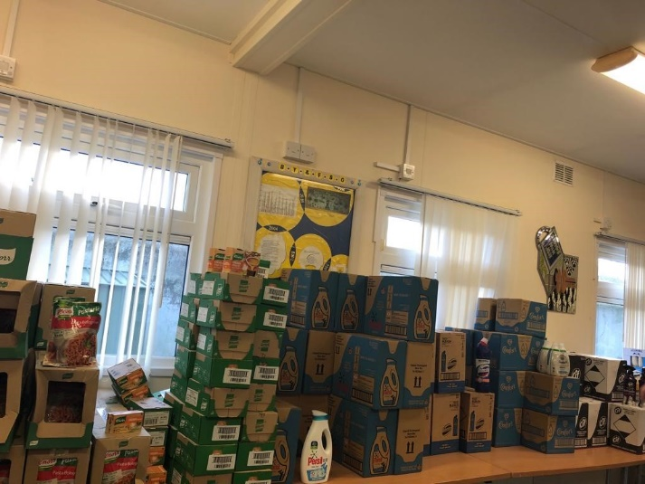

Donation of Period Poverty Hygiene products

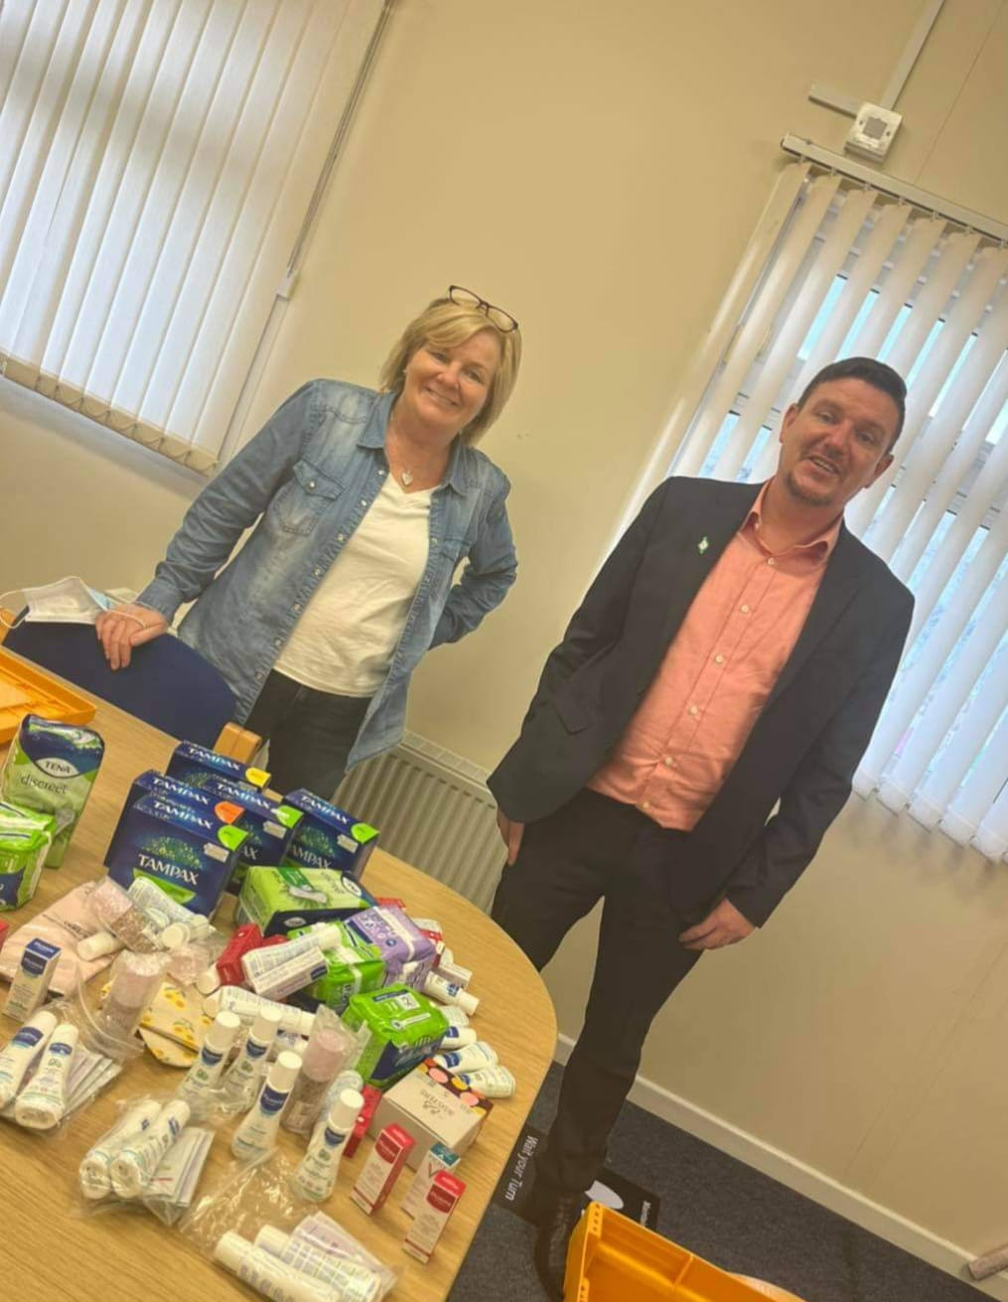

On behalf of Management, staff and Volunteers at Clondalkin Tús Nua, we would like to take this opportunity to thank you all.

Organisation chart

Board of Management and Staff Group

Board of Management
Brian Scanlan
Kathleen O’Sullivan (Treasurer)
Jamie Doran (Chairperson)
Margaret Lawlor
Félim Ó Maolmhána
William Carey

Clondalkin Tús Nua staff:
1 Project Manager
1 Deputy Manager
1 Community Employment Supervisor
1 Community Employment Assistant Supervisor
2 Key workers
1 Family Support Worker
1 Outreach Worker
1 Assertive Case Manager
9 C.E. participants

Clondalkin Tús Nua - Station 1 Rehabilitation Day programme:
1 Rehabilitation Team leader
1 Community Employment Supervisor/key worker
1 Community Employment Assistant Supervisor/key worker
29 C.E. Rehabilitation Participants

Funding sources
HSE Section 39 / Clondalkin Drug & Alcohol Task Force
Once off grants Clondalkin Drug & Alcohol Task Force
Department of Social Protection
TUSLA Family Support Agency
Financial Summary
Clondalkin Tus Nua have completed our financial audit for 2022 and the following extract was taken from the Directors report and Financial Statements for the year ended 31st December 2022 and approved by the board on the 23rd May 2023

2022 2021
Income
Donations | 5,330 |  | 13,006
Department of Social Protection | 502,679 |  | 494,439
LDTF - Treatment & Rehabilitation | 249,311 |  | 249,311
LDTF - Prevention Programme | 71,066 |  | 71,066
HSE | 124,352 |  | 119,796
CDTF Once Off Income | 10,270 |  | 9,001
TUSLA | 6,968 |  | 7,035
Safe Program Strand | 30,000 |  | 60,000
HSE - Pay Restoration | 12,009 |  | 22,556
HSE - Inflation Support Funds | 17,036 |  | -
Other income | 569 |  | 8,557
 | ─────── |  | ───────
 | 1,029,590 |  | 1,054,767
 | ─────── |  | ───────

Expenditure
Materials | 1,565 |  | 938
Wages and salaries | 792,207 |  | 776,198
Employers PRSI contributions | 44,418 |  | 44,349
Staff/ Participants Training | 16,485 |  | 9,299
Drop In Costs | 1,465 |  | 2,979
Once Off Funding | 11,491 |  | 8,885
Rent payable | 20,875 |  | 24,510
Insurance | 20,736 |  | 20,510
Equipment Costs | 9,553 |  | 7,827
Light and heat | 11,838 |  | 10,149
Repairs and maintenance | 14,228 |  | 12,741
Printing, postage and stationery | 6,645 |  | 8,191
Advertising | 540 |  | 900
Telephone | 7,330 |  | 6,715
Computer costs | 8,626 |  | 10,918
Tusla - Parent Support Counselling | 9,740 |  | 5,145
Legal and professional | - |  | 615
Rehabilitation Programme Costs | 11,936 |  | 6,675
Bank charges | 782 |  | 738
Donations/ Fundraising | 2,000 |  | 2,744
General expenses | 5,119 |  | 4,442

Auditor's remuneration | 6,835 |  | 6,335
Depreciation | 18,093 |  | 34,844
 | ─────── |  | ───────
 | 1,022,507 |  | 1,006,647
 | ─────── |  | ───────

Finance
Other interest | - |  | 566
 | ─────── |  | ───────

Net surplus | 7,083 |  | 47,554
 | ═══════ |  | ═══════

