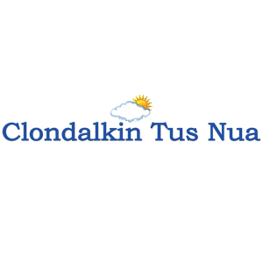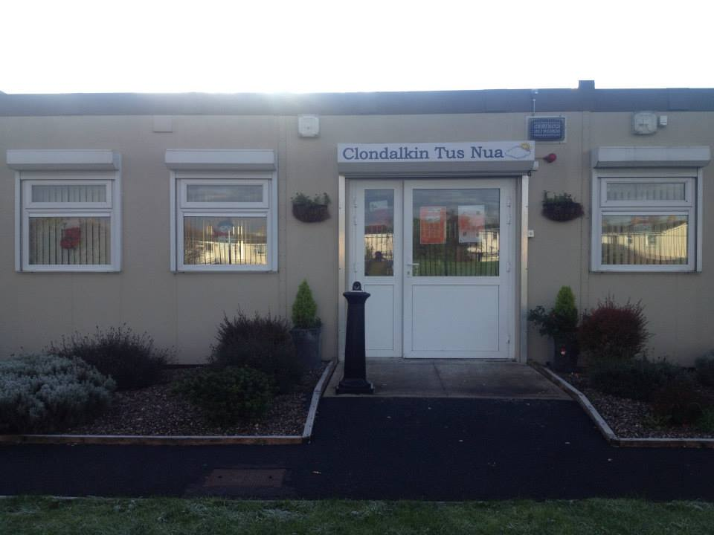
ANNUAL REPORT
2017

New Nangor Road, Clondalkin, Dublin 22
Tel: 01 4572938
Registered Charity Number: 20102586
www.clondalkintusnua.ie

Contents Page

About Us 4

Services provided 5

In this year 12

Staff and Board of Management 13

Annual events in 2017 14

A copy of this report is available on our website www.clondalkintusnua.ie

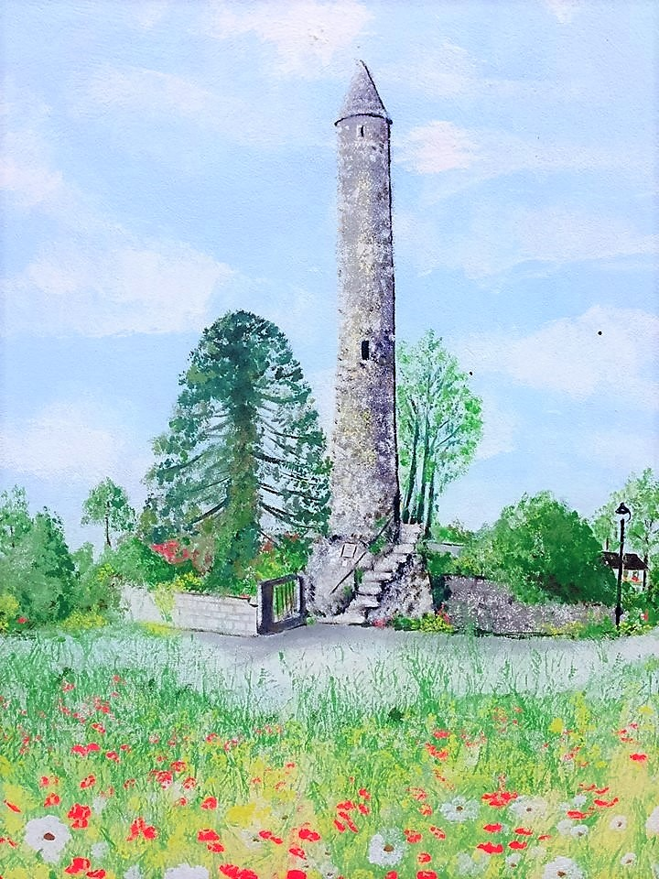

About Clondalkin Tus Nua

Clondalkin Tus Nua is a community based addiction support group based in the South West Clondalkin area of Dublin, The project was established in 1996 as a response to the local drug problems in the area. As a community we sought solutions to the drug problems in the area. This was achieved by developing practical and effective ways of working with statutory agencies and local service providers. Through funding from the Health Service Executive, D.S.P. and the Clondalkin Drugs and Alcohol Task Force Clondalkin Tus Nua opened in September 1999. The centre is the first port of call for those requiring advice or information on issues of drug use and misuse. To date our centre remains accessible to anyone who wishes to avail of the wide range of services. Using a holistic approach we endeavour to provide service’s that cater for the needs of the mind, body and spirit of the service users. These services are delivered in a professional manner that is flexible in a locally based, accessible venue and include Addiction Support, Rehabilitation Day Programme and Family Support.
2017 was an extremely busy year for the project with increased numbers of service users presenting to the service. It is hoped that this report will give the reader an insight into the service delivered by Clondalkin Tus Nua.

For more information please log on to:

www.clondalkintusnua.ie

Services provided by
Clondalkin Tus Nua in 2017

Client work

- Drop in:
Light refreshments and hot meals/snacks are an extremely important part of our drop-in service, as for many of our clients this may be the only food they avail of on that day. It is also an opportunity to disseminate homeless packs and can provide a gateway into other services provided in Clondalkin Tus Nua
- Homeless drop in 09.30 to 11.00 am
- Morning Open access drop in 10.00 to 11.00 am
- Homeless drop in 02.30 to 04.00 pm
- Afternoon Open access drop in 03.00 to 04.00 pm

- Clients availed of Drop in service 91
- Individual attendances 1333
- Clients went on to engage in the key working process 9

- Homeless Service
- 2 x Daily Homeless drop in, hot food, showers and laundry service
- South Dublin County Council Homeless outreach worker provides support/information to homeless service users every second Wednesday afternoon 2.30pm to 4.00pm
- Support when accessing homeless shelters/accommodation etc.
- Hygiene packs/Health Promotion
- Referrals to relevant agencies

Availed of homeless service 23

- Addiction support sessions:
Monday to Thursday 9.00am to 5.00pm
Friday 9.00am to 4.00pm

To provide one to one sessions, set in a confidential and safe environment. Sessions could involve any of the flowing interventions:
- Initial assessments
- Comprehensive assessments
- Relapse prevention
- Crisis intervention
- Harm Reduction
- Motivational Interviewing
- Individual Care plans
- Referrals to Treatment centres, counsellors, education/employment etc.,
- Referrals to mental Health Services
- Progression routes
- Pre assessments
- Community reintegration

Client list

Total client List 2017 92

- Gender Specific:
To provide gender specific supports in relation to education, training, development of life skills, as well as to enhance and encourage emotional and personal development. Whether it is gender specific health issues, life skills, relationship or parental rights issues we can raise awareness within our client group and promote the need for a gender balanced approach to these issues.

- Referrals for Counselling :

TUSLA Child and Family Agency provide a budget to provide counselling to family members.

- Complimentary Therapies:
Complimentary therapies are utilised in our project as part of our holistic approach to dealing with substance abuse. The uses are many fold in both situations where either clients or family members of those in addiction avail of this service. For individual clients these therapies contribute to reducing mental and physical stress levels and help to promote the clients ability to relax and in turn help in increasing the clients clear headedness when engaging in the service through the key working process. For clients who are near to entering residential treatment or are undertaking a home detox, complimentary therapies are indispensable in helping those suffering withdrawal symptoms and in general through releasing tension. For family members, complimentary therapies provide a vital “time out” or respite from the depression many suffer as a result of living through the process of addiction in the family

- Outreach/Harm Reduction Service:
We provide a street based outreach service to work with the growing number of drug users, homeless or at risk of homeless service users in Clondalkin. Promoting harm reduction and good health/safe sex practice. Building non judgemental, supportive relationships with homeless/active drug users.

Street based Harm Reduction Service
Monday to Thursday 9.00am to 4.45pm
Friday 9.00am to 3.45pm

Number of Exchanges 1134

Number of Service Users Met 151
Harm reduction clients accessed key working 7

- Station 1 - Rehabilitation Day Programme

2 x 19.5 hours per week of which 16 hours are delivered on a group basis
In 2006 Clondalkin Tus Nua highlighted the lack of locally based CE rehabilitation places suitable for drug users in the early stages of recovery. Responsibility was given to Clondalkin Tus Nua and Clondalkin Drug Task Force Treatment & Rehabilitation Sub-Group to develop a proposal for a community based Rehabilitation Project
In December 2007 Clondalkin Tus Nua launched the Station 1 Rehabilitation & Development Programme
Station 1 is a D.S.P. sponsored rehabilitation day programme, tailored to meet the needs of individuals in recovery from substance dependency.
Our aim is to provide a therapeutic setting to focus on returning to work and gaining economic/social independence, while providing a continuum of support in relation to recovery needs.
The main elements of the programme are Educational, Holistic and Therapeutic

Education:
Our Educational Interventions are based on:
- Providing a learning environment that is Interactive, Collaborative and enjoyable.
- Providing material that is relevant to the needs of the participant group.
- Neutralising any negative associations from previous learning environments

Holistic
- Encouraging the participant to include healing strategies that support the whole person.
- Providing tools that help and increase control over one's behaviour in positive ways.
- Reducing tension, anxiety, depression and insomnia, improving overall mental, physical wellbeing.

Therapeutic
- Providing a core concept form that feeds into all elements of the programme.
- Providing group setting in which participants can gain a deeper understanding to the process of addiction.
- Providing and promoting a peer support setting to enable participants to relate with each other in a caring and supportive way.

C.T.N. (Station 1 Rehabilitation Programme) Client support:
- Pre programme Induction supports
- P1 – Stabilisation Programme
- P2 – Recovery prep programme
- P3/4 – Drug Free Programme
- P5 – Integration Phase

Clients accessed services in Station 1 59

Pre programme induction supports 34

- 11 clients referred on to P3/P4 Drug Free Programme
- 4 clients referred on to P1 Stabilisation Programme
- 8 clients reengaged for additional aftercare supports.
- 5 clients felt treatment was complete after shot-term interventions (4-8 weeks)
- 4 clients currently working on pre programme bases
- 2 clients referred back to main services in CTN

P1 Stabilisation Programme 12

- 3 clients completed this phase and achieved drug/alcohol free status and were referred on to P3/4 Drug free programme
- 7 clients continued to attended this programme and have improved their quality of life, illicit drug use has decreased and participation with other support service increased.
- 2 clients discontinued with the programme due to drug intake / health issues

P2. Recovery Preparation Programme 8
- 1 client completed Cuan Dara Residential Detox, and referred back to our P3/4 Drug free programme
- 1 client completed Rutland Residential centre and returned to our P3/4 Drug free programme
- 1 client completed detox in New Hope and was referred to P3/4 Drug Free Programme
- 5 clients still on programme

P3/4 Drug Free Programme 26

- 7 clients completed day programme and moved into employment
- 1 client left the programme early due to health issues/ relapse
- 1 client moved onto BTI educational programme
- 7 clients accessed work placement through P3/4 ACE programme
- 4 clients completed community addiction studies QQI L5
- 3 client attending part-time 3rd level educational courses

P5. Integration Phase 7

- 7 clients accessed work placement from P3/4 Drug free programme

Aftercare – not Community Employment 13

- 13 clients accessed aftercare supports in Station 1. These supports included key working and case management, referrals for additional supports, brief and crisis interventions.

- Family Support
Family support is an integral tenant of the service our project provides. This support takes the form of one to one sessions, crisis intervention, education/therapeutic workshops, referrals for counselling, group support, and much more. It is implicit through the amount of work we do in this area that family support remains a vital resource of our projects holistic approach to the challenge addiction represents in our community.
Through one to one sessions the family support worker is able to assess and identify the individual family members needs, develop a specific care plan and implement the supports needed. This is the most personal way in which we can address our family’s needs.

With the Wednesday night family support group we foster peer support from within the community and help family members develop crucial networks of peer support and friendship which help to minimise the feelings of isolation and self blame which are so common around addiction in the family.

- Open access Contact centre
- One to one support
- Group support
- Education/Therapeutic workshops
- Access to counselling
- Complimentary therapies

Monday to Friday 9.00am to 5.00pm
Friday 9.00am to 4.00pm

- Individual family members accessed one to one support sessions. 53
- Members attending weekly group support 11
- Family members attended education and therapeutic work shops 24

In this year

Dual Diagnosis Seminar

Christina Smith, Addiction Support Worker with Clondalkin Tus Nua in conjunction with Clondalkin Mental Health Service presented at the
Dual Diagnosis Seminar
Clondalkin – September 2017

Community Addiction Services available to Service Users
- Community Addiction Services
- Clondalkin Mental Health
- Services Provided
- Programmes Available
- Current Presenting Issues for Community Addiction Services
- Current Presenting Issues for Community Mental Health
- Current Challenges in Relation to Responding to Mental Health Within a Community Drugs Project
- Current Challenges in Relation to Responding to Substance Misuse Within a Community Mental Health Team
- Formalised Shared Care Locally
- Case Study – ‘Mary’
- Key Successes Locally

Presentation is available on request

The project continues to receive donations from FEAD, BIA FOODS AND FOODCLOUD These donations enable the project to support families in need and supports our daily drop in’s.

Staff Group

Main Service:
1 Project Manager
1 Community Employment Supervisor
1 Community Employment Assistant Supervisor
2 Key workers
1 Family Support Worker
1 Outreach worker
9 C.E. participants
1 Tus participants

Station 1 Rehabilitation Day programme
1 Rehabilitation Coordinator
1 Community Employment Supervisor/key worker
1 Community Employment Assistant Supervisor/key worker
1 Project worker
2 C.E. support workers
27 C.E. Rehabilitation participants

Board of Management
Brian Scanlan (Chairperson)
Kathleen O’Sullivan (Treasurer)
Michelle Kearns
Judith Edmunds
Shane Lynch
Jamie Doran
Councillor Mark Ward

Annual events 2017

Women’s international day 8th March 2017

79 Women attended for:

- Relaxing Therapies

- Group meditation

- Lunch

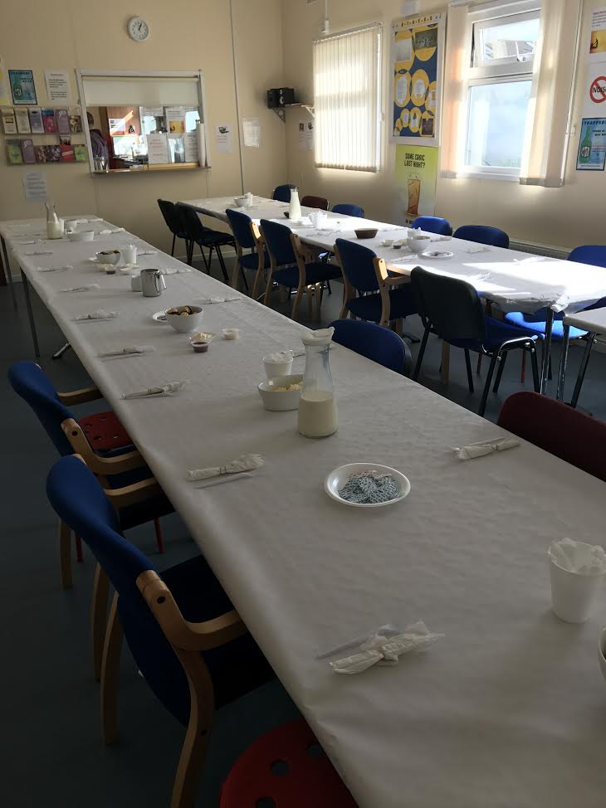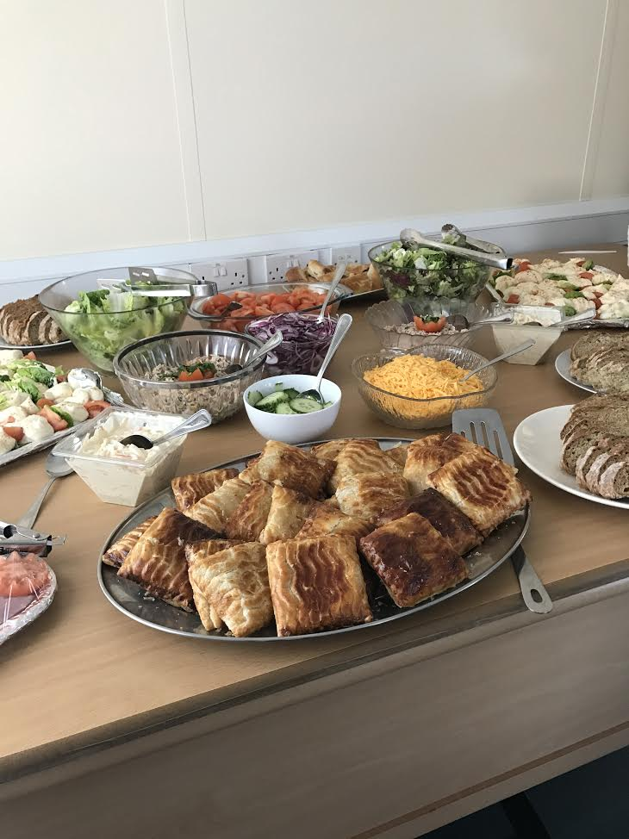

In June 2017 the project hosted a family Fun Day for service users.

This was a very successful day and approximately 120 adults and children attended.

The day included:

- Face painting
- Arts and crafts activities
- Fun and Games
- Karaoke
- BBQ and Pizza’s

Annual Lighting of the Christmas Tree

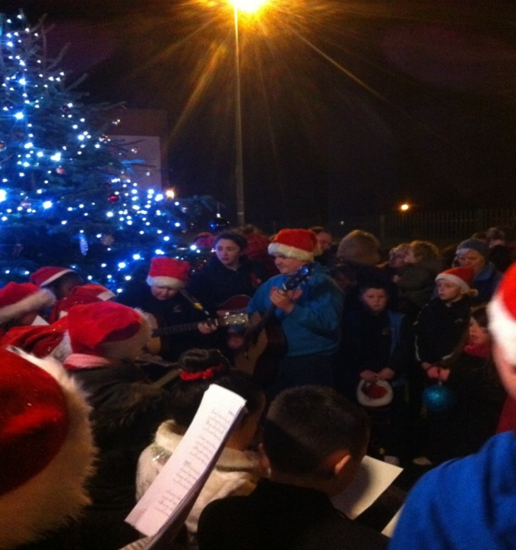

Approximately 100 service user’s attended the annual lighting of our Christmas tree followed by Carol singing and a special visit from Santa and his elves

Preparations for client annual Christmas dinner

17 came for dinner, followed by pool competition and karaoke with Christmas gifts etc.,

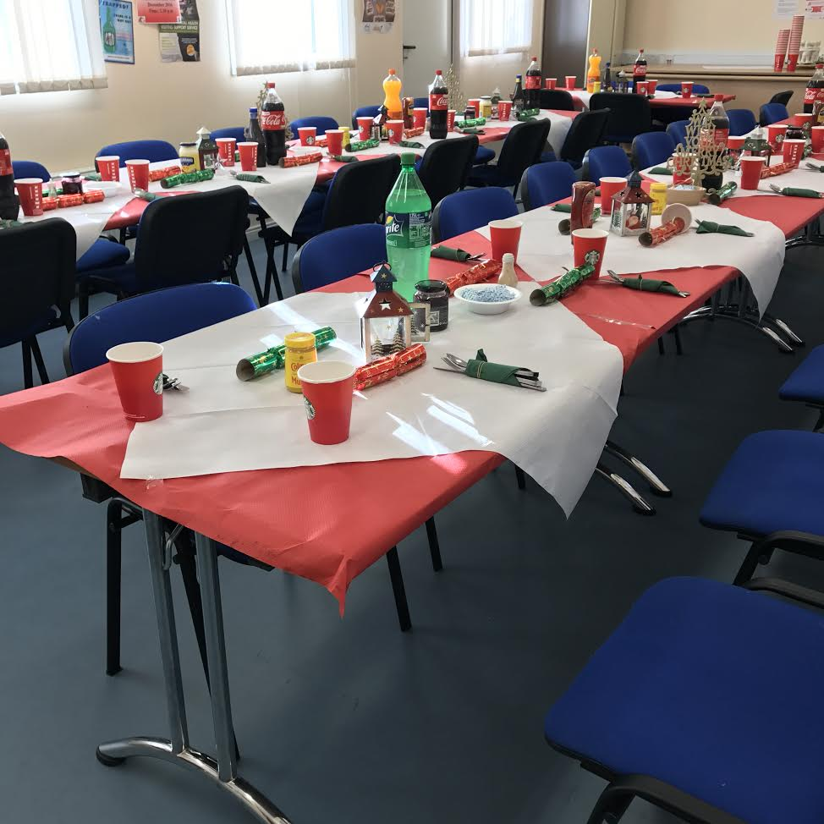

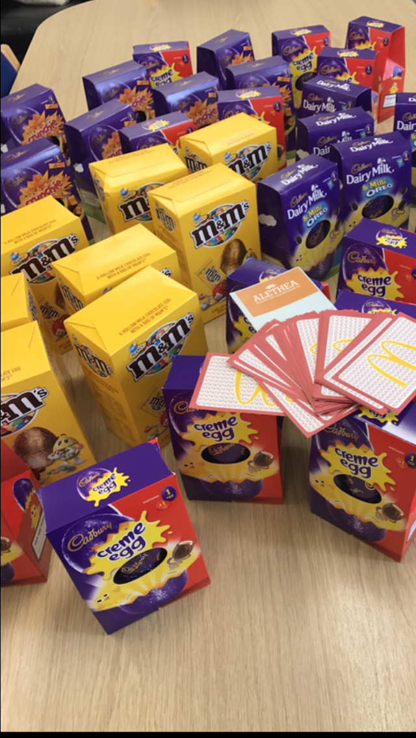

The project received a donation of 50 Easter eggs and Mc Donald’s vouchers from Althea Counselling Service. We were able to provide rough sleepers with the vouchers for over the Easter holidays

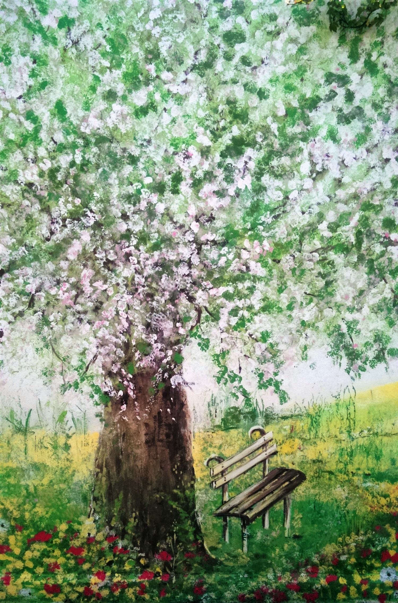
Clondalkin Tus Nua – Back wall Mural



